Security And User Administration

Default Users:
Root - Super User
Adm, sys, bin - This Ids that own system files but cannot be
used for login

Each user has a unique name, numeric ID and password.
Every user is a member of at least one group and can be a member of several groups.

Root is system group whereas the staff group is for all ordinary users.
Only root can add/remove/change an admin user or admin group.

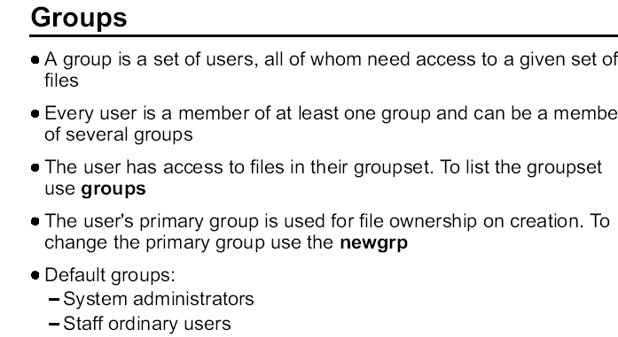

Users that require shared access to a set of files are placed in groups. A user can belong to multiple groups. Each group has a unique name and Group ID (GID). The GID is also assigned to a file when it is created.

There are several groups predefined on an AIX system. For example, the system group is root's group and the staff group is for all ordinary users.
The creation of groups to organize and differentiate the users of a system or network is part of systems administration.

The guidelines for forming groups should be part of the security
policy. Defining groups for large systems can be quite complex and once a system is operational, it is very difficult to change the group structure. Investing time and effort in devising group definitions before your system arrives is recommended.

Groups should be defined as broadly as possible and be consistent with your security policy. Do not define too many groups because defining groups for every possible combination of data type and user type can lead to impossible extremes.

A group administrator is a user who is allowed to assign the members and administrators of a group. It does not imply that the user has any administrative abilities for the system.

There are three types of groups on the system:

User Groups

User groups should be made for people who need to share files on the system, such as people who work in the same department, or people who are working on the same project.

System Administrator Groups

System administrators are automatically members of the system group. Membership of this group allows the administrators to perform some of the system tasks without having to be the root user.

System Defined Groups

Several system-defined groups exist. staff is the default group for all non-administrative users created in the system. security is another system-defined group having limited privileges for performing security administration. The system-defined groups are used to control certain subsystems.

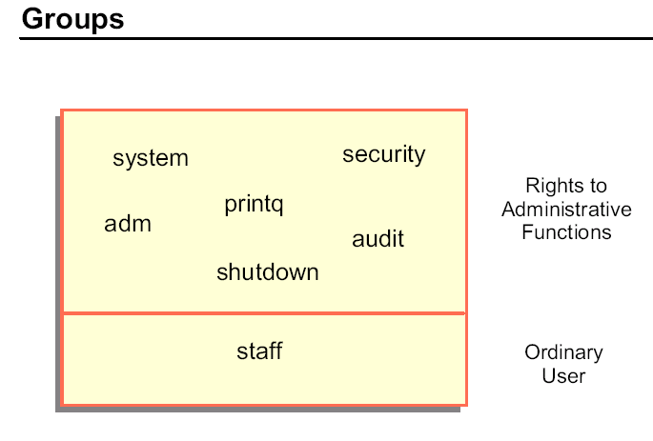

Common groups on the system are:

system For most configuration and standard hardware and software
maintenance.
printq For managing queuing. Typical commands which can be run by
members of this group are: enable, disable, qadm, qpri, and so forth.
security To handle most passwords and limits control. Typical commands which can be run by members of this group are: mkuser, rmuser, pwdadm, chuser, chgroup, and so forth.
adm Most monitoring functions such as performance, cron, accounting
staff Default group assigned to all new users. You may want to change this in /usr/lib/security/mkuser.defaults.
audit For auditors.
shutdown Allows use of the shutdown command.

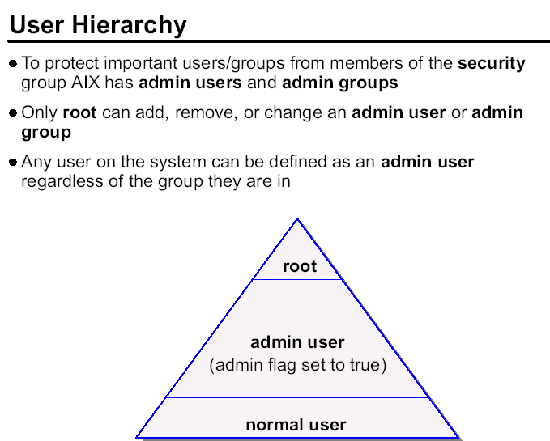

The ability to perform certain system tasks (like creating users) depends upon the standard AIX file permissions. Most system admin tasks can be performed by users other than root by assigning those users to groups such as system, security, printq, cron, adm, audit or shutdown. In particular, a user in the security group can add/remove/change other users and groups.

To protect important users/groups from users in the security group, AIX has three levels of user hierarchy: root, admin users/groups and normal users/groups. Only root can add, remove, or change an admin user or admin group. Therefore, you can define a user with a high level of access, but who is protected from users in the security group.

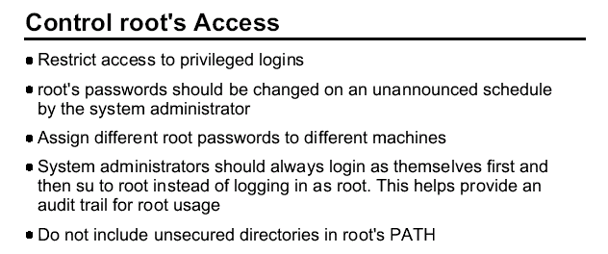

If the root password is known by too many people, no one can be held accountable. The root password should be limited to just two or three administrators. The fewer people who know root's password the better.

The system administrator should ensure that distinct root passwords are assigned to different machines. You may allow normal users to have the same passwords on different machines, but never do this for root.

Attempts to become root through su can be investigated. Successful and unsuccessful attempts might be logged by the audit system.

root's PATH is used by many implicit system functions, not just by a user logged in as root.

To illustrate important concept with root security.

- Having different passwords on every machine may cause a problem if there are lots of machines. This needs to be done sensibly. Administrators could create a password scheme that makes each password slightly unique but not impossible to remember.

- Be sure to point out the dangers of having an unsecured directory
in root's PATH. This include the dot (.) for the current directory.
You might want to use an example like:

PATH=.:/usr/bin:/usr/sbin

Since the dot (.) represents the current directory, the root user might accidentally execute something in that directory. A user on the system could creates a destructive file call “ls” that contains the one line to delete all the files on the system “rm -r /”. If the root user's is in that user's home directory and tries to perform a file listing, instead of /usr/bin/ls running, it will find ./ls first. When this file is run by the unsuspecting system administration at the root level, the system will be destroyed.

If the user normally logs in as a regular user and su's to root, the regular account's PATH should also avoid using unsecured directories. Remember, with the su command, if the dash (-) is not used, then the current environment is kept (that includes PATH).

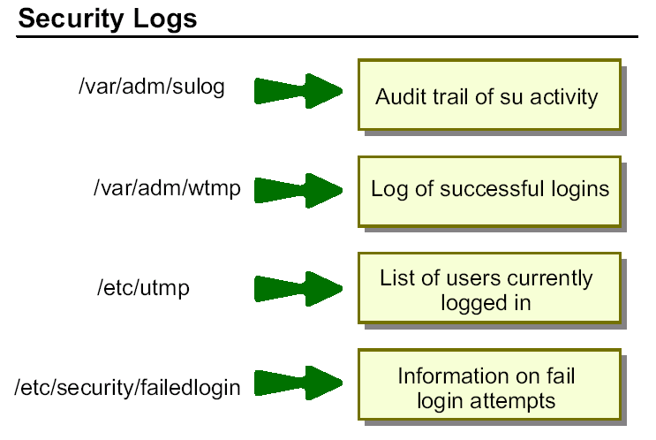

The sulog file is an ASCII text file that can be viewed with more or pg. In the file, the following information is recorded: date, time, terminal name and login name. The file also records whether the login attempt was successful (and indicates a success by a + and a failed login by a -).

The /etc/utmp file contains a record of users logged into the system, and the
/var/adm/wtmp file contains connect-time accounting records. To obtain information from either file use the who command with the file name. The who command normally examines the /etc/utmp but you can specify either one of the named files as arguments to the command.

The last command can also be used to display in reverse chronological order, all previous logins and logoffs still recorded in the /var/adm/wtmp file.

The /var/adm/wtmp file collects login and logout records as these events occur and holds them until the records are processed by the accounting commands.

For example:

last root displays all the recorded logins and logoffs by the user root
last reboot displays the time between reboots of the system

AIX V5.2 introduces a new daemon called utmpd, to manage the entries in the /etc/umpd file. The validity of the user process entries are monitored at regular intervals. The default interval time would be 300 seconds.

The syntax of the command is:
/usr/sbin/utmpd [ Interval ]

To start utmpd from the /etc/inittab, add the following entry to the file:
utmpd:2:respawn:/usr/sbin/utmpd

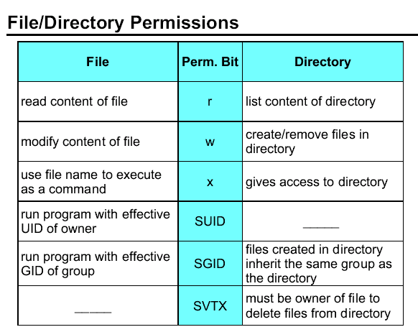

There are a number of permission bits associated with files and directories. The standard r (read), w (write) and x (execute) permissions define three levels of access for the user (owner), group and others. In addition there are three permission bits known as SUID (set UID), SGID (set GID) and SVTX (sticky bit).

SUID on an executable file means that when the file runs, the process runs with an effective UID of the owner of the file. SUID is not supported on shell scripts.

SUID has no meaning on a directory.

SGID on an executable file means that when the file runs, the process runs with an effective GID of the group owner of the file. SGID on a directory means that any file/directory created within the directory will have the
same group ownership as the directory rather than the primary group of the user.

SVTX on a file has no meaning in AIX (It was used in earlier versions of UNIX.) SVTX on a directory means that even if the directory has global write permission (for example, /tmp), users cannot delete a file within it unless they either own the file or the directory.

Traditional UNIX used SVTX to keep a program in memory after it had completed running, but with memory management routines, this is no longer necessary. SVTX is known as the sticky bit.

The SGID permission bits are propagated down through the directory structure, so that any directory created in a directory with the SGID bit set also inherits that bit.

Examine the effect that permissions have on files and directories.

- Read permission on a file allows the contents to be examined. The cat, pg and more command will work successfully if r is set on the file. Read on the directory allows the content of the directory to be seen (use the ls command). Keep in mind that a directory is a file in UNIX; it is a file that contains a list of ordinary files. Therefore, r has the same effect on both files and directories - it allows you to see the content.
- Write permission allows the content to be changed. On a file,
this mean modifying the content with an editor (like vi) or
with redirections (> or >>). On a directory, modifying the
content means adding or removing a file from the directory (rm,
vi,touch).
- The execute permission on a file allows the file to be executed
by using the name of the file as a command. A shell script without
this permission can still be executed, however the shell must
be specified as part of the command. For example:
# ksh file1 or # . ./file1.

Execute on a directory gives permission to access the directory. This includes using cd to enter the directory or just running a command that resides in that directory. All the parent directories must have execute permission as well to allow access to a subdirectory.

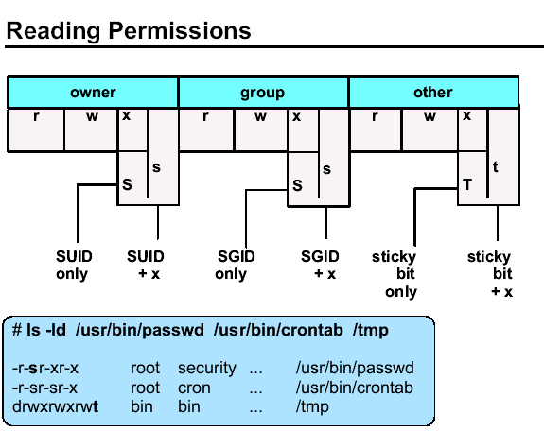

The SUID bit is indicated by an S or s in the slot normally reserved for the execute permission for owner (user). The SGID bit is indicated by an S or s in the slot normally reserved for the execute permission for group. The SVTX bit is indicated by a T or t in the slot normally reserved for the execute permission for others. Since this slot must show if execute is on/off and whether the additional permission bit on/off, the uppercase S or T indicates that the execute permission is off. The lower case s or t indicates the execute permission is on.

There are three examples of files that use these additional permissions. The passwd command allows users to change their password even though passwords are stored in a restricted area. crontab allows users to create a crontab file even those the directory where these files reside is restricted from ordinary users. And /tmp allows everyone to write to the directory, but only the owner of a file can remove a file from the /tmp directory.

Show how the AIX permissions appear when set against files and directories.

- In the example, the passwd command has SUID set. This allows users to change their passwords, which are stored in encrypted format in the /etc/security/passwd file. You may want the students to run the ls -l command against this file.
They will see that only the root user has rw permissions on this file. Because SUID is set for the passwd command, ordinary users will temporarily become the root user and be able to write their new passwords to the /etc/security/passwd file.
- The crontab command allows users to set their personal crontab
file. The directory (/var/spool/cron/crontabs) where the file resides
is a restricted directory. Without the SUID and SGID bits set, the
user would not be able to create or modify the crontab file.
- Because the sticky bit is set for the /tmp directory, users can
only delete, rename, and so forth, their own files in that directory.

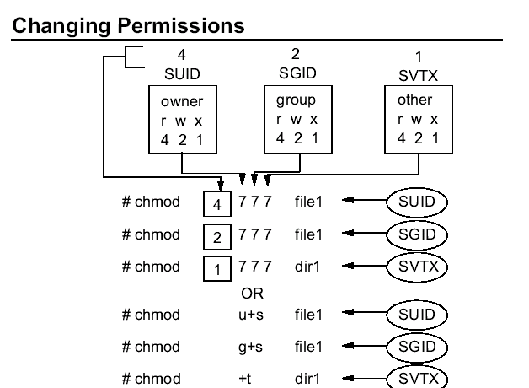

To set the additional permission bits, you use the same command (chmod) as you do to set the regular permission bits.

If using the octal notation, you are probably familiar with setting permissions using a command like:

# chmod 777 file1.

When you issue this command, the more complete command would be: # chmod 0777 file1. The fourth number, a zero, is implied. This fourth
position determines whether the additional bits are turned on.
You normally use the binary values of 4, 2, and 1 to set r, w and x. That remains the same.

To set the additional bits, you are affecting the x position in either the user, group or other area. If you assign binary values to user (4), group (2), and other (1), these are the values that you insert into the fourth position to set the additional bit. SUID is indicated in the user's area; therefore use a 4 in the fourth position. The SGID is indicated in the group area; therefore use a 2 in the fourth position. The SVTX is indicated in the others area; therefore use a 1 in the fourth position.

You can also use the symbolic methods.

The uppercase S or T indicates that the execute permission is off
The lowercase s or t indicates the execute permission is on.

The binary value 4 at the fourth position of user bits area indicates additional bit set implied SUID permission bit sets on a file.

# chmod 4777 file1 => indicates SUID on file1

The binary value 2 at the fourth position of group bits area indicates additional bit set implied GUID permission bit sets on file1

# chmod 2777 file1 => indicates GUID on file1

Similarly binary value 1 indicates for SVTX bit set on the file1

# chmod 1777 file1 => indicates SVTX on the file1.

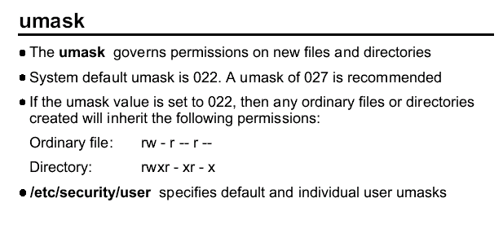
The umask governs permissions on new files and directories. The system default umask is 022. An umask of 027 indicates tighter security permissions for newly created files and directories.

If no umask was used, then file would be created with permission of 666 and directories would be created with permissions of 777.

I umask is set, then the initial permission for files are 644 and for directories, 755 for default umask of 022.

And for the default umask of 027, the initial permission for the files are 640.

For the current session to view the umask the command is:
# umask

For the current session to change the umask the command is
# umask 027

The umask is specified in /etc/security/user.

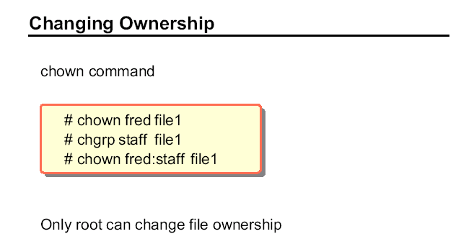

Ownership Commands

# chown user1 file1
change ownership of file to user1

# chgrp group1 file1
change ownership of group to group1

# chown user1:group1 file2
change the file2 to user1:group1 ownership.

Redirecting stdin, stdout, and stderr

The operating system allows you to manipulate the input and output (I/O) of data to and from your system by using specific I/O commands and symbols. You can control input by specifying the location from which to gather data.

For example, you can specify to read input entered on the keyboard (standard input) or to read input from a file. You can control output by specifying where to display or store data. For example, you can specify to write output data to the screen (standard output) or to write it to a file.

File descriptors

When a command begins running, it usually expects that the following files are already open: standard input, standard output, and standard error.
A number, called a file descriptor, is associated with each of these files. The default assignments for these descriptors are as follows:

0 Represents standard input (stdin)

1 Represents standard output (stdout)

2 Represents standard error (stderr)

These file descriptors are connected by default to the terminal, so that if a program reads file descriptor 0 and writes file descriptors 1 and 2, the program collects input from the terminal and sends output also to the terminal.

Redirecting input (stdin)

When the notation < filename is added to the end of a command, the default file descriptor for input of the command is changed, and input is read from the specified file name. The < (less than) symbol is known as the input redirection operator.

For example, to send the file letter1 as a message to user denise with the mail command, type:

# mail denise < letter1
#

Using inline input (here) documents

If a command is followed by the notation << eofstring and eofstring is any string that does not contain pattern-matching characters (for example *), then the shell takes the subsequent lines as the standard input of the command until the shell reads a line consisting of only eofstring (possibly preceded by one or more tab characters).

The lines between the first eofstring and the second are frequently referred to as an inline input, or here document. If a hyphen (-) immediately follows the << redirection characters, the shell strips leading tab characters from each line of the here document before it passes the line to the command.

Note: Only commands that normally take their input from the keyboard can have their input redirected.

The here document is especially useful for a small amount of input data that is more conveniently placed in the shell procedure rather than kept in a separate file (such as editor scripts).

For example, you could type:

# cat <<- xyz
> This message will be shown on the
> display with leading tabs removed.
> xyz

This message will be shown on the
display with leading tabs removed.
#

Redirecting output (stdout)

The output of a command can be redirected to a file typing the command followed by the notation > filename. For example, to save the value of the PATH variable on a file, type:

# echo $PATH > path
#

To see the contents of the path file, type:

# cat path
/usr/bin:/etc:/usr/sbin:/usr/ucb:/usr/bin/X11:/sbin:/usr/java14/jre/bin:/usr/ja
va14/bin

Redirecting output and appending to a file

When the notation >> filename is added to the end of a command, the output of the command is appended to the specified file name, rather than writing over any existing data. The >> symbol is known as the append redirection operator.

For example, we want to add the contents of file2 at the end of file1:

# cat file1

This is line1

# cat file2
This is line 2

#cat file2 >> file1
#

The result is:

# cat file1
This is line 1
This is line 2
Creating a text file with redirection from the keyboard

Used alone, the cat command uses whatever you type at the keyboard as input. You can redirect this input to a file. Enter Ctrl-D on a new line to signal the end of the text.

At the system prompt, type:

# cat > test
This is a test.
^D

The contents of the file test is:

# cat test
This is a test.
#

Concatenating text files

Combining various files into one single file is known as concatenation.
For example, we have three files, and we want to integrate the information at these three files into a single one. The contents of each file is:

# cat file1
This is line 1

# cat file2

This is line 2
# cat file3
This is line3
#

Type the following command to concatenate all of them on file4:

# cat file1 file2 file3 > file4
#

Looking at the contents of file4 gives us the following result:

# cat file4
This is line 1

Note: If the file1 file does not exist, it is created, unless the no clobber option of the set built-in ksh (Korn shell) or csh (C shell) command is specified.

This is line 2
This is line 3
#

The previous example created file4, which consists of file1, file2, and file3, appended in the order given.

The following example shows a common error when concatenating files:
# cat file1 file2 file3 > file1
#

Redirecting standard error (stderr)

In addition to the standard input and standard output, commands often produce other types of output, such as error or status messages known as diagnostic output. Like standard output, standard error output is written to the screen unless redirected.

To redirect standard error output, type the file descriptor number 2 before the output or append redirection symbols (> or > >) and a file name after the symbol.

For example, the following command tries to list a file that does not exist on the system:

# ls -l dailyTasks.sh
ls: 0653-341 The file dailyTasks.sh does not exist.
#

Redirecting stdout gives us this result:

# ls -l dailyTasks.sh > list
ls: 0653-341 The file dailyTasks.sh does not exist.

#

If we look at the contents of file list:

# cat list
#

it has no content at all.

Note: In this example, you might expect the cat command to append the contents of file1, file2, and file3 into file1. The cat command creates the output file first, so it actually erases the contents of file1 and then appends file2 and file3 to it.

In this case, the command is sending its output to stderr, so in order to save this message on a file, you should type:

# ls -l dailyTasks.sh 2> list
#
No message is sent to the screen. If we look at the contents of file list, we can see that it now has contents in it:

# cat list
ls: 0653-341 The file dailyTasks.sh does not exist
#

Examples

You can redirect stdin, stdout, and stderr individually or group them (stdout and stderr only). For example, to list the files on a directory, run:

# ls *.dat *.txt > files.out 2> files.err
If we look at the contents of file files.out:

# cat files.out
names.dat
source.dat
people.dat

and the contents of files.err:

# cat files.err
ls: 0653-341 The file *.txt does not exist

you may find some cases where you just want to keep all the output (stdout and stderr) in one single file. You can do this by using the following notation:

command > output 2>&1

The listing files example above can be changed to:

# ls *.dat *.txt > files.out 2>&1

And the contents of the file files.out looks like:

# cat files.out
ls: 0653-341 The file *.txt does not exist
names.dat
source.dat
people.dat

For example, you are given the task to automate an ftp command transfer and log all the events related to that transfer:

#ftp -n -iv server <<EOT >>results.ftp
user yourUser yourPassword
ascii
get file1
bye
EOT

Summary

As we have shown, the following symbols redirect I/O, and when used, the shell's default file descriptor assignments are changed. You can combine them to meet your administration tasks and keep control when using I/O operations on commands or shell scripts.

Table 5-1 provides a list of redirection symbols and their meanings.

Note: The ampersand character (&) after the greater than symbol (>) does not mean that this command should run as a background process; instead, you are instructing the shell that stderr must be redirected where stdout is.

Table 5-1 Redirection Symbols
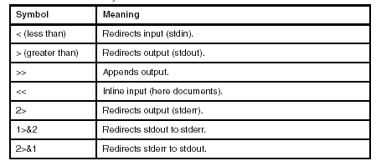

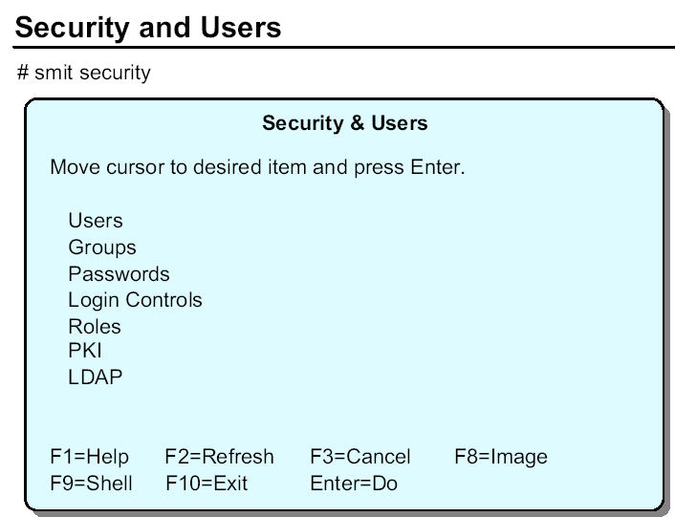

The Security and Users menu is used to manage user and group IDs on the system. The menu consists of five options:

• Users - This option is used to add users to the system, delete existing users and change the details of existing users.

• Groups - This option is used to add groups to the system, delete groups and change the details of existing groups.

• Passwords - This option is used to change the password for a user. It is required when setting up a new user or when a user has forgotten their password.

• Login Controls - This option provides functions to restrict access on a user account or on a particular terminal.

• Roles - This option sets up user roles. User roles allow root to give authority to an ordinary user to perform a portion of root's functions.

• PKI - PKI stands for X.509 Public Key Infrastructure certificates. This option is used to authenticate users using certificates and to associate certificates with processes as proof of a user’s identity.

• LDAP - LDAP stands for Light Directory Access Protocol. It provides a way to centrally administer common configuration information for many platforms in a networked environment. A common use of LDAP is the central administration of user authentication. The smit option here allows us to configure this platform as either an ldap client or an ldap server.

The Web-based System Manager can also be used to manage users and groups.

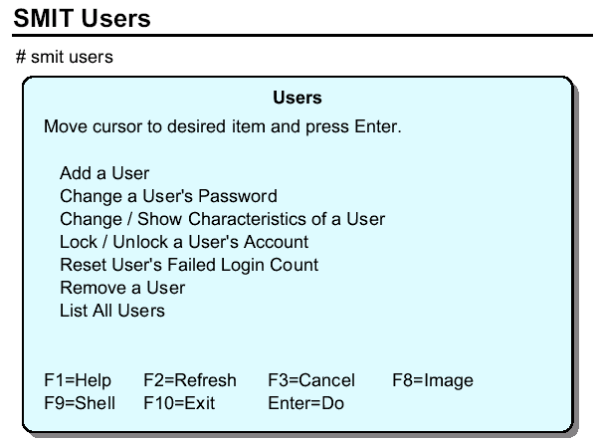

Add a User - Add user accounts.

Change a User's Password - Password changes.

Change/Show Characteristics of a User - Changes the many characteristics that are a part of the user account. The password restrictions are part of this area.

Lock/Unlock a User's Account - This is used to temporarily disable an account. It is a good security practice to disable accounts if they are not expected to be used, like when someone is on an extended leave of absence.

Reset User's Failed Login Count - If the administrator has set a limit to the number of failed attempts that can be made on an account before locking it, this resets that count.

Remove a User - Removes the user account, but not files owned by that user.

List all users - Runs the lsuser command.

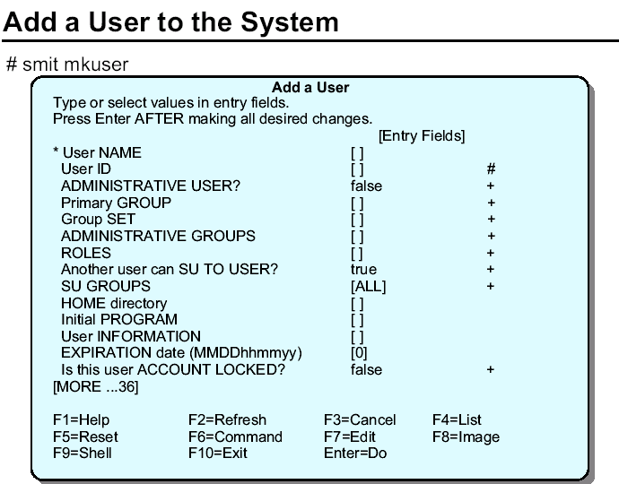

Default ID numbers in: /etc/security/.ids
Shell script to set up ID: /usr/lib/security/mkuser.sys
Default characteristics in: /usr/lib/security/mkuser.default
/etc/security/user
Default .profile: /etc/security/.profile

The mkuser command is used to add a user. User attributes can be specified to override the default values.

The only required value is the user name. Traditionally this name was restricted to 8 characters in length.

In AIX 5.3, this limit can be changed to allow names as long as 255
characters. The limit is modified in the Change/Show Attributes of the
Operating System panel (smit chsys).

The defaults for the mkuser command are stored in the file
/usr/lib/security/mkuser.default. This file can only be edited by the root user. This file contains the following information:

user:
pgrp = staff
groups = staff
shell = /usr/bin/ksh
home = /home/$USER

admin:
pgrp = system
groups = system
shell = /usr/bin/ksh
home = /home/$USER

The user stanza of this file is picked up if an ordinary user is being added and the admin stanza is picked up if an administrative user is being added.
If the user ID is not specified, then a default ID number is chosen from the
/etc/security/.ids file. Administrative users are given IDs starting from 6 and normal users starting from 200.

The shell script /usr/lib/security/mkuser.sys is run during the user creation process. This creates the user's home directory and creates the .profile file. This shell script can be modified to perform any function that is required when setting up the user.

The full list of user characteristics contains some entries which are not often used. Many of these fields may be left empty with no ill-effect. For the complete list refer to SMIT (fastpath smit mkuser).

When a new user is created the ID is disabled (an asterisk is placed in the password field of the /etc/passwd file). To enable the ID a password must be set with the Change a User's Password option or the passwd or pwdadm commands.

The following command can be used to change/show characteristics of a user:
# chuser attribute=value username

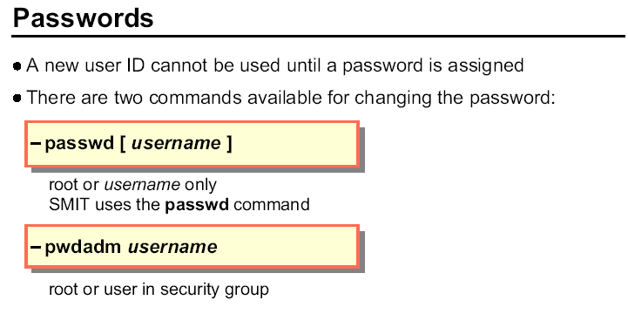

When a user ID is created with SMIT or with the mkuser command, the user ID is disabled (an * is in the password field of /etc/passwd. To enable the ID, the passwd or pwdadm command must be used to set up the initial password for the user.

When passwords are entered, they are not displayed. When changing a password, the new password is requested a second time for verification.

If root or a member of the security group sets the password for a user, the ADMCHG flag is set in the flags field in /etc/security/passwd. The user is then prompted to change the password at the next login.

The difference between the passwd command and the pwdadm command is
as follows:

Whenever the passwd command is executed, no matter who you are on the system, the system will always require the user's old password before allowing the change EXCEPT if you are logged in as the root user. Then no password is requested. However, this could cause a problem, when all the user accounts and passwords are administered by the members of security (who do not necessarily know the root password).

What will happen if one of the ordinary users forgets their password and requests a new password from the security group? If there was no other command this would not be possible using the passwd command because in this situation we neither know the old password, nor root's password.

Commands

To displays all the recorded logins and logoffs by the user root. # last root

To displays the time between reboots of the system # last reboot

To display how many users are currently logged in
#who
To prints a summary of current activity on the system(user,tty,idle,login etc)
#w

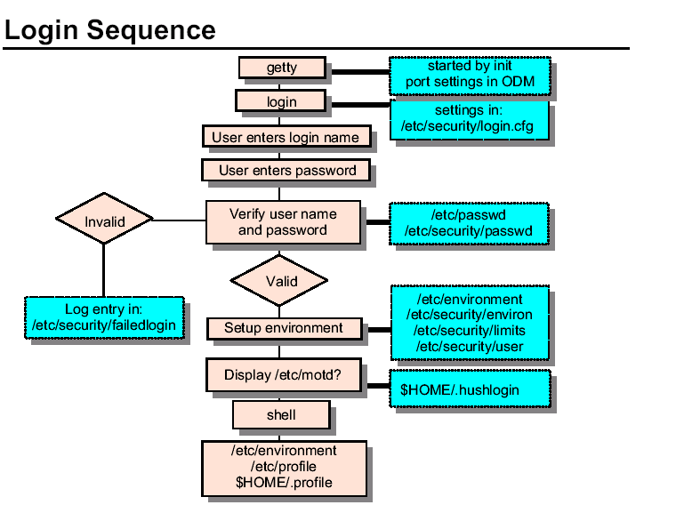

The Login Sequence

The ports setup for login are listed in the /etc/inittab file.

When init runs, a getty process will be started for each port in the list providing a login prompt on the terminal attached to that port. The actual message displayed by the getty process is defined in /etc/security/login.cfg. The getty process waits for a user to make a login attempt.

When a user is ready to login, they enter their user name at the login prompt. The login program is passed the user name and then checks /etc/passwd and /etc/security/passwd to see if a password is required. If a password is required or the user name doesn’t match a valid name, the “Password:” prompt is displayed and the “invis” terminal attribute is set so that the password is not displayed as it is entered.

When the user enters the password, it is checked. If it is incorrect or an invalid user name was given, then the login fails and an entry is made in the /etc/security/failedlogin file.

To view the /etc/security/failedlogin file the command is
# who /etc/security/failedlogin

The number of failed login attempts is also tracked by
# who /etc/security/lastlog

If a user successfully enters the user name and password, the ‘usw’ stanza in ‘/etc/security/login.cfg’ is checked. This stanza sets the maximum number of concurrent logins for a user account. If that number is exceeded, the login is denied and a message is displayed to the user.

If everything is successful to this point, then the user’s environment is set using ‘/etc/environment’, ‘/etc/security/environ’, ‘/etc/security/limits’ and ‘/etc/security/user’.

The login program sets the current directory to the user’s HOME directory and displays the content of ‘/etc/motd’ (if no .hushlogin file is found in the HOME directory), date of the last successful login, and the number of unsuccessful login attempts since the last successful login.

Finally, control is passed to the login shell ( as defined in /etc/passwd) which will run /etc/profile and $HOME/.profile when using Korn or Bourn shells.

When a user logs out, the shell will terminate and a new getty process will be spawned for that port.

In the past, /etc/passwd and /etc/security/passwd were
searched sequentially to find the user's ID and password. This was adequate in the days when there were just a few users per system. Now, there may be hundreds or thousands of users on a system. If these files are read sequentially, and the user's entry is near the end of the file, it is possible for the login attempt to timeout before completion.

Also, the amount of cpu time being consumed by the login process is becoming cause for concern.

In AIX, this can be addressed by creating indexes of these two login files. The files themselves have not been changed. Students may notice the indexes in the system: For example, the indexes for the /etc/passwd file are /etc/passwd.nm.idx and /etc/passwd.id.idx.

The indexes are created when the mkpasswd -f command is executed. It deletes any existing indexes and builds new indexes.

The /etc/security/lastlog file is also indexed in AIX.

/var/adm/wtmp also is updated during the login and logout process. This file keeps track of times for a successful logins and logouts. It can be read using "who /var/adm/wtmp" or the command last.

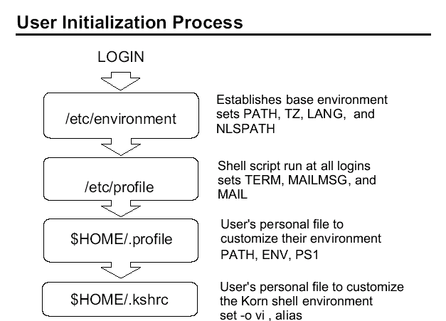

At Login :

/etc/environment => sets base environment HOME, LANG, TZ, and
NLSPPATH
/etc/profile => sets Shell script run at all logins sets TERM,
MAILMSG, and MAIL
$HOME/.profile => sets user’s personal file to customize their
environment

/etc/environment is used to set variable. No commands should be placed in this file.

/etc/profile will be read and executed during every login.

/etc/environment and /etc/profile can be changed only by root.

$HOME/.profile and $HOME/.kshrc can be customized by the user. The user can overwrite any variable set in /etc/environment and /etc/profile.

When working with CDE the .dtprofile file is used to establish the environment. The .dtprofile replaces the function of .profile in the CDE environment. If you want to use the functionality of both .profile and .dtprofile, uncomment the line near the end of the file that references the DTSOURCEPROFILE variable.

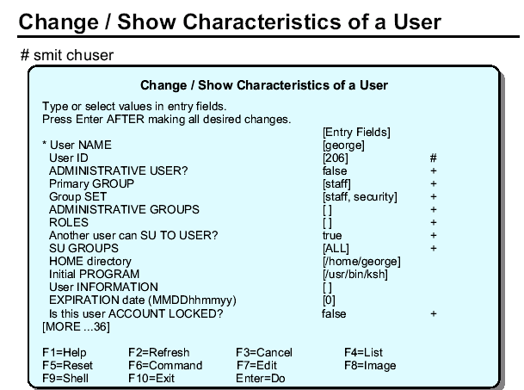

The Change / Show Characteristics of a User option which runs the chuser command, allows any of the user characteristics listed previously (except the user name) to be changed. This can only be executed by root or a member of the security group (only root can change an admin user). This SMIT screen holds exactly the same attributes as the Add a User screen.

The user information is not required by the system. This is the fifth field in the /etc/passwd file which is usually used to hold the user's real name, telephone number, and so forth.

Some programs use this information when reporting on user activity for example, the finger program in TCP/IP. Users can change their own user information.

The initial program is the shell which the user logs into. It is usually set to one of:

/usr/bin/bsh (the Bourne shell)
/usr/bin/csh (the C shell)
/usr/bin/ksh (the Korn shell) (default)

A user can only change their shell to one of the above whereas root can change a user's shell to any program. Also note that users can change their own full name and login shell.

The following command can be used to change/show characteristics of a user:

# chuser attribute=value username

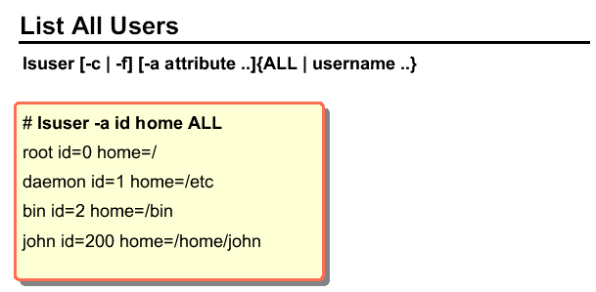

The lsuser command is used to list the attributes of all users (ALL) or individual users on the system. When the List All Users option in SMIT is used, the user name, id and home directory are listed.

When the command is issued directly, the data may be listed in line format, in colon format (-c) or in stanza format (-f). Individual attributes or all attributes may be selected.

The output can also be generated for individual users.

The information is gathered from the various security files: /etc/passwd,
/etc/security/limits and /etc/security/user.

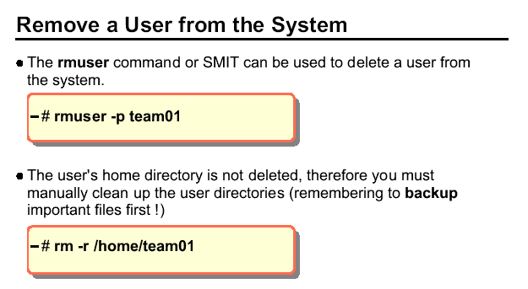

The Remove a User from the System option or the rmuser command can be used to remove any user from the system. Only the root user may remove administrative users.

The -p option removes authentication information from the /etc/security/* files. Typically this information is the user password, as well as other login restrictions which have been previously set for the ID.

The user's home directory and associated files are not removed by this option. They must be removed separately by the administrator. To do this you can use the -r option on the rm command to recursively remove files. Remember to back up any important files before removing the user's home directory.

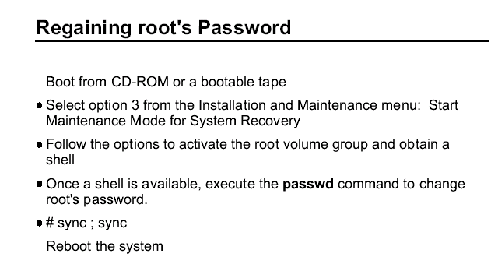

To recover the root password, you must boot your machine from media other than its normal hard drive. An installation CD or a mksysb tape works just fine. Remember to invoke the service boot list - usually by pressing F5 while your machine is booting.

You will need to define your system console and select a language. Then the installation and maintenance menu will display. Be certain to select option 3

- Start Maintenance Mode for System Recovery. If you select option 1 or 2, you are reinstalling your operating system.

You need to activate the root volume group and start a shell. This gets you access to rootvg without any passwords. Once you get the # prompt, just use the passwd command like you normally would.
Run # sync ; sync. This ensures the memory buffer is written to disk. In other words, it ensures the new password is saved to disk.

Then reboot your system - shutdown -Fr.

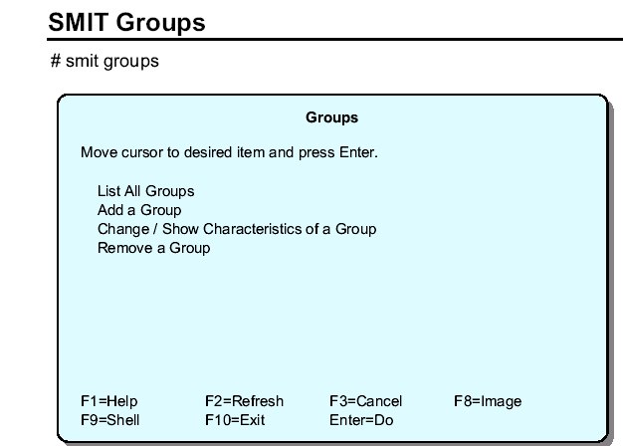

The purpose of groups is to give a common set of users the ability to share files. The access is controlled using the group set of permission bits.

Only root and members of the security group can create groups. Root and security group members can select a member of the group to be the group administrator.

This privilege allows the user to add and remove users from the group.
Remember there are a number of predefined groups on AIX systems like the system group (which is root's group) and the staff group (which contains the ordinary users).

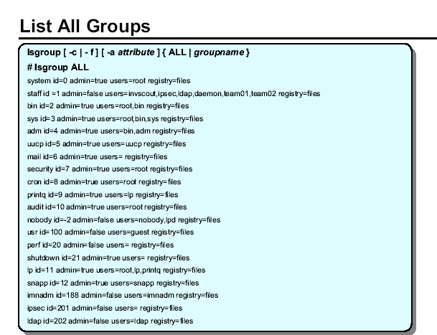

The lsgroup command is used to list selected or all groups on the system. The data is presented in line format by default or in colon format (-c) or in stanza format (-f).

The -c option displays the attribute for each group in colon separated records.

The -f option displays the group attributes in stanza format with each stanza identified by a group name.

A user can belong to up to 32 groups.

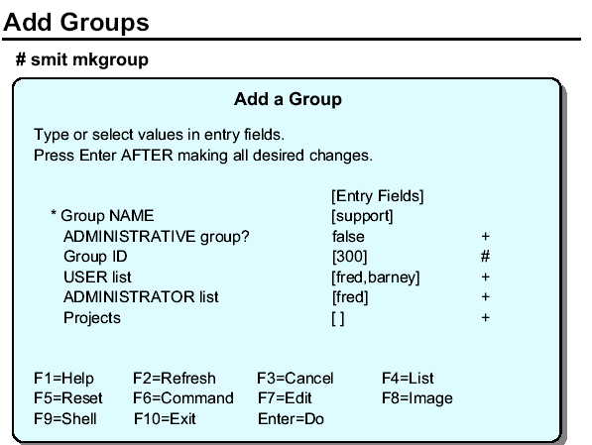

The mkgroup command is the command used to create a new group. The group name, traditionally, must be a unique string of eight characters or less. With AIX V5.3 and later, the maximum name length can be modified to be as large as 255 characters.

The (-a) parameter is used to indicate that the new group is to be an administrative group. Only the root user can add administrative groups to the system.

The (-A) option makes the invoker of the mkgroup command the group administrator.

A user may belong to no more than 32 groups. ADMINISTRATOR list is a list of members from the USER list that are allowed to change the characteristics of a group and add or remove members.

Staring with AIX 5.3, there is a new option, projects, for tracking resource usage in the Advanced Accounting provided in AIX 5.3.

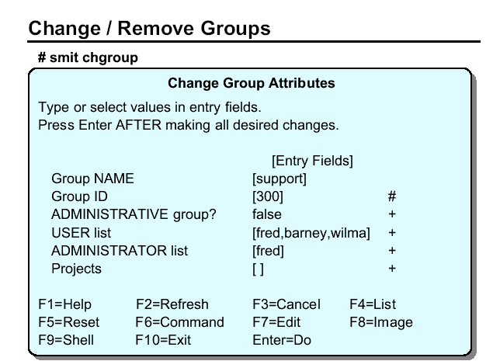

The chgroup command is used to change the characteristics of a group. It can only be run by root or a member of the security group. The group attributes are:

• Group ID (id=groupid). It is not advisable to change the groupID, but it is occasionally done immediately after a group has been created to match the ID of a previously deleted group, or a specific groupID for a particular software package.

• ADMINISTRATIVE group? (admin=true|false). Only the root user can change a group to be an administrative group or make changes to an existing administrative group.

• USER list (users=usernames). This is a comma separated list of the names of all the members of the group. The group may be their primary group or an additional one.

• ADMINISTRATOR list (adms=adminnames). This is the list of group administrators.

The chgrpmem command can be used by any user to change either the administrators or the members a group for which they are group administrator.

The rmgroup command is used to remove a group from the system. This command has no options and the only parameter is the group name. Only the root user can delete an administrative group.

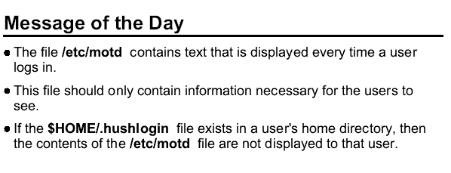
This is a convenient way to communicate information to all users, such as installed software version numbers or current system news. The message of the day is contained in the /etc/motd file.

To change the message of the day, simply edit this file.

Many other commands exist to communicate with the user community. Several of these commands are covered in the AIX Version 5.2 Basics course such as write, wall, mail and talk.

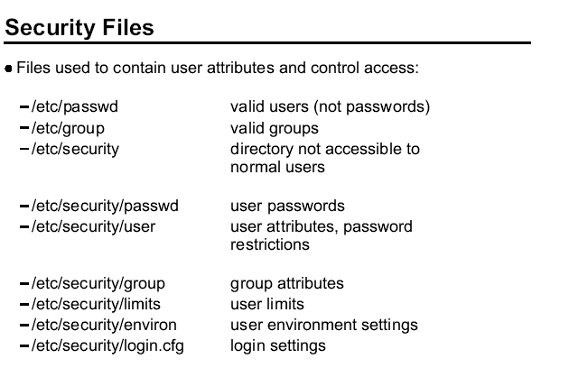

The security on the system is controlled by a number of ASCII files.

The /etc/passwd file lists the valid users, their user ID, primary group, home directory and default login shell.

The /etc/group file lists the valid groups, their group ID and members.
The above files have global read access to all users. A number of other files control the attributes of users. They are in the /etc/security directory which can only be accessed by root or the security group.

/etc/security/passwd contains the encrypted password and update information for users.

/etc/security/user contains extended user attributes.

/etc/security/group contains extended group attributes.

/etc/security/limits contains process resource limits for users.

/etc/security/environ contains environment variables for users. This file is not often used.

/etc/security/login.cfg is a configuration file for the login program. This contains security enhancements that limit the logins on a port, for example, the number of login attempts and the valid login programs (shells).

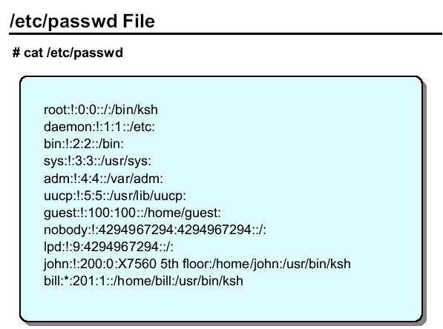

The /etc/passwd file lists the users on the system and some of their attributes. This file must be readable by all users, because commands such as ls access it.

The fields in the /etc/passwd file are:

• user name - up to eight alphanumeric characters (not all upper case)
• password - on older UNIX systems this contained the encrypted password.

This will still work, but since AIX Version 5.1 it cannot contain the encrypted password and should contain a ! to refer to the /etc/security/passwd file. Other common values are a * which
means the id is invalid, and no value means there is no password assigned.

• uid - the user ID number for the user
• gid - the ID of the primary group to which this user belongs
• information - any descriptive text for the user
• directory - the login directory of the user and the initial value of the $HOME variable

• login program - Specifies that the initial program or shell that is executed after a user invokes the login command or su command.

In AIX, additional files can be created to be used as an index for the /etc/passwd, /etc/security/passwd and /etc/security/lastlog files. These index files provide for better performance during the login process. Use the mkpasswd -f command to create the indexes. The command mkpasswd -c can be used to check the indexes and rebuild any that look suspicious.

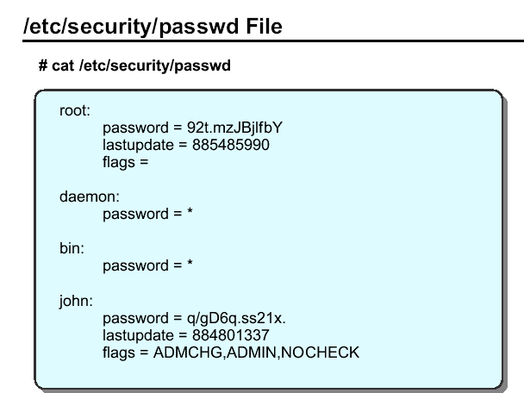

The /etc/security/passwd file can only be accessed by root. The login, passwd, pwdadm and pwdck commands (which run with root authority) update this file. This file is in stanza format with a stanza for each user. The valid entries are:

• password Either the encrypted password or * for invalid, or blank for no
password

• lastupdate The date and time of the last password update in seconds from
January 1, 1970

• flags ADMCHG - the password was last changed by an administrator or
root
ADMIN - the user's password can only be changed by root
NOCHECK - password restrictions are not in force for this user.
(see /etc/security/user for password restrictions)

In AIX, additional files can be created to be used as an index for the /etc/security/passwd file. These index files provide for better performance during the login process. These indexes are created using the mkpasswd command.

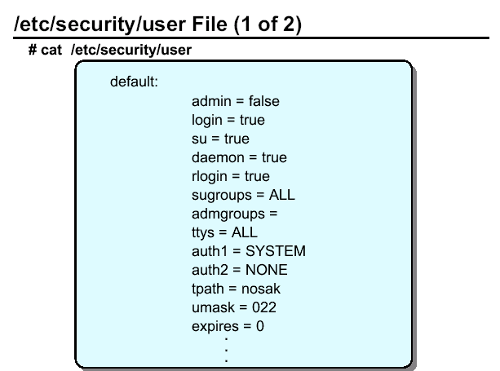

admin
Defines the administrative status of the user. Possible value: true or false.

login
Defines whether a user can login. Possible values: true or false.

su
Defines whether other users can switch to this user account. The su command supports this attribute. Possible values: true or false.

daemon
Defines whether the user can execute programs using the system resource controller (SRC). Possible values: true or false.
rlogin
Defines whether the user account can be accessed by remote logins. Commands rlogin and telnet support this attribute. Possible values: true or false.

sugroups
Defines which groups can switch to this user account. Alternatively you may explicitly deny groups by preceding the group name with a ! character. Possible values:
A list of valid groups separated by commas, ALL or *

admgroups
Lists the groups that a user administers. The value is a comma-separated list of valid group names.

ttys
Defines which terminals can access the user account. Alternatively you may explicitly deny terminals by preceding the terminal name with the ! character.
Possible values: List of device paths separates by commas, ALL or *

auth1
Defines the primary authentication method for a user, which by default is set to the password program. The commands login, telnet, rlogin and su support these authentication methods.

auth2
Defines the secondary authentication methods for a user. It is not a requirement to pass this method to login.

tpath
Defines the user's trusted path characteristics. Possible values: nosak, notsh, always or on. (For more information refer to online documentation).

umask
Defines the default umask for the user. Possible values: 3-digit octal value.

expires
Defines the expiration time for the user account. Possible values: a valid date in the form MMDDHHMMYY or 0. If 0, the account does not expire. The 'YY' supports the last two digits of the years 1939 to 2038. If 0101000070 then the account is disabled.

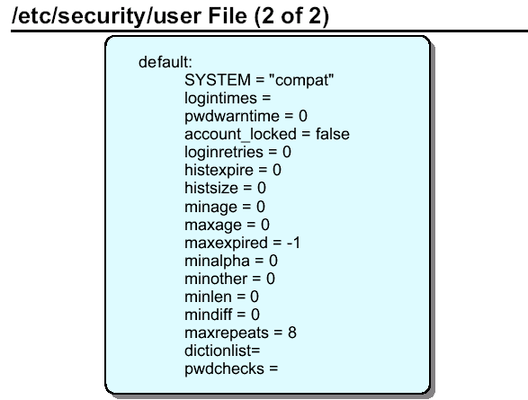

SYSTEM

This attribute can be used to describe multiple or alternate authentication methods the user must use successfully before gaining access to the system. Possible tokens are:

files which allows only local users access to the system

compat which is the normal login procedure and therefore allows local and NIS users access to the system

DCE which is the Distributed Computing Environment authentication.

Logintimes
Defines the times a user can login. The value is a comma separated list of items as follows:
[!][MMdd[-MMdd]]:hhmm-hhmm
or
[!]MMdd[-MMdd][:hhmm-hhmm]
or
[!][w[-w]]:hhmm-hhmm
or
[!]w[-w][:hhmm-hhmm]

where MM is a month number (00=January, 11-December), dd is the day on the month, hh is the hour of the day (00 - 23), mm is the minute of the hour, and w is a weekday (0=Sunday, 6=Saturday).

pwdwarntime
The number of days before a forced password change that a warning is given to the user
informing them of the impending password change. Possible values: a positive integer or 0
to disable this feature.

account_locked
Defines whether the account is locked. Locked accounts cannot be used for login or su. Possible values: true or false.

loginretries
The number of invalid login attempts before a user is not allowed to login. Possible values: a positive integer or 0 to disable this feature.

histexpire
Defines the period of time in weeks that a user will not be able to reuse a password.

Possible values: an integer value between 0 and 260. 26 (approximately 6 months) is the recommended value.

histsize
Defines the number of previous passwords which cannot be reused. Possible values: an integer between 0 and 50.

minage
Defines the minimum number of weeks between password changes. Default is 0. Range: 0 to 52.

maxage
Defines the maximum number of weeks a password is valid. The default is 0, which is equivalent to unlimited. Range: 0 to 52.

maxexpired
Defines the maximum number of weeks after maxage that an expired password can be changed by a user. The default is -1, which is equivalent to unlimited. Range: -1 to 52. maxage must be greater than 0 for maxexpired to be enforced. (root is exempt from maxexpired).

minalpha
Defines the minimum number of alphabetic characters in a password. The default is 0. Range: 0 to 8.

minother
Defines the minimum number of non-alphabetic characters in a password. The default is 0. Range: 0 to 8.

minlen
Defines the minimum length of a password. The default is 0. Range: 0 to 8. Note that the minimum length of a password is determined by minlen and/or "minalpha + minother", whichever is greater. "minalpha + minother" should never be greater than 8. If "minalpha + minother" is greater than 8, then minother is reduced to "8 - minalpha".

mindiff

Defines the minimum number of characters in the new password that were not in the old password. The default is 0. Range: 0 to 8.

maxrepeats
Defines the maximum number of times a given character can appear in a password. The default is 8, which is equivalent to unlimited. Range: 0 to 8.

dictionlist
Defines the password dictionaries used when checking new passwords. The format is a comma separated list of absolute path names to dictionary files.

A dictionary file contains one word per line where each word has no leading or trailing white space.

Words should only contain 7 bit ASCII characters. All dictionary files and directories should be write protected from everyone except root. The default is valueless which is equivalent to no dictionary checking.

pwdchecks
Defines external password restriction methods used when checking new passwords. The format is a comma separated list of absolute path names to methods or method path names relative to /usr/lib. A password restriction method is a program module that is loaded by the password restrictions code at run time.

All password restriction methods and directories should be write protected from everyone except root. The default is valueless, which is equivalent to no external password restriction methods.

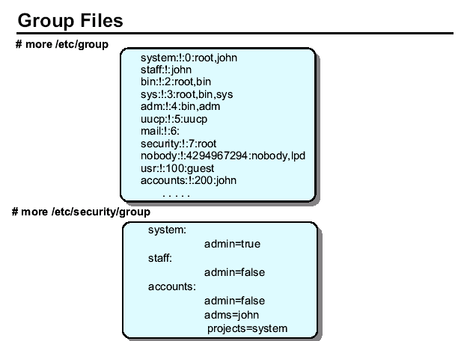

The fields in the /etc/group file are:

• group - up to eight alphanumeric characters (not all upper case)
• password - this field is not used in AIX and should contain a !
• gid - the group ID
• members - a comma-separated list of the users who belong to this group

The /etc/security/group file is a stanza file with one stanza for each group. The valid entries are:

admin true or false, whether the group is an administrative group

adms a comma-separated list of the users who are administrators for the group. If admin=true this stanza is ignored because only root can change an
administrative group.

projects a list of project names to be associated with the group

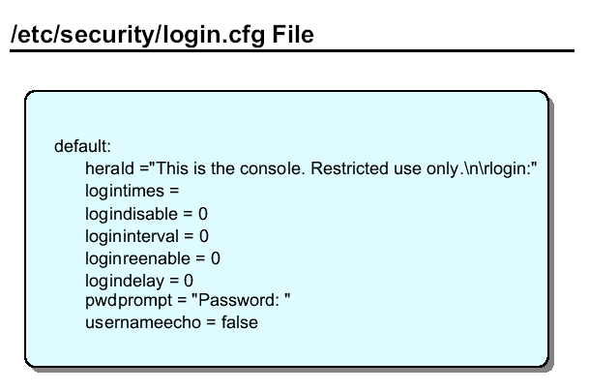
herald
Specifies the initial message to be printed out when getty or login prompts for a login name.

This value is a string that is written out to the login port. If the herald is not specified, then the default herald is gotten from the message catalog associated with the language set in /etc/environment.

logintimes
Defines the times a user can use this port to login.

logindisable
Number of unsuccessful login attempts before this port is locked. Use this in conjunction with logininterval.

logininterval
The number of seconds during which logindisable unsuccessful attempts must occur for a port to be locked.

loginreenable
The number of minutes after a port is locked that it automatically unlocked.

logindelay
The delay in seconds between unsuccessful login attempts. This delay is multiplied by the number of unsuccessful logins - that is, if the value is two, then the delay between unsuccessful logins is two seconds, then four seconds, then six seconds and so forth.

pwdprompt
Defines the password prompt message printed when requesting password input. The value is a character string.

usernameecho
Defines whether the user name should be echoed on a port. If true, this is the default, the user name echo is enabled. If false, user name echo is disabled. The user name is not echoed at the login prompt and is masked out of security-related messages.

Changes to the /etc/security/login.cfg file can be done by the command

chsec:

# chsec -f /etc/security/login.cfg -s default -a pwdprompt=”Password:”
# chsec -f /etc/security/login.cfg -s default -a
pwdprompt=”usernameecho=false”

To reset to the default value:
# chsec -f /etc/security/login.cfg -s default -a pwdprompt=

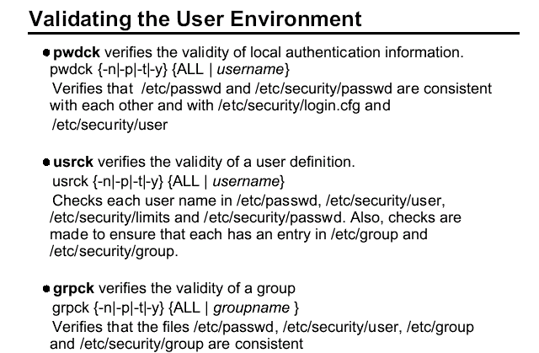

These commands can be executed by root or any user in the security group to clean up after a change to the user configuration. Because they run with root permissions, they give administrative users the ability to make necessary changes to the /etc/security/passwd file in a controlled way, without knowing the root password.

The usrck command verifies the validity of the user definitions in the user database files, by checking the definitions for ALL the users or for the users specified by the user parameter. You must select a flag to indicate whether the system should try to fix erroneous attributes.

All the options for pwdck, usrck, and grpck are as follows:

-n reports errors but does not fix them

-p fixes errors but does not report them

-t reports errors and asks if they should be fixed

-y fixes errors and reports them

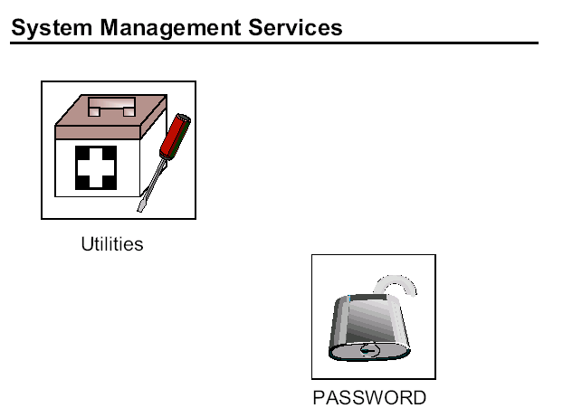

The power-on and privileged passwords are security features that help protect the information on a your RS/6000.

These passwords can only be enabled or disabled through the Utilities menus in the System Management Services menus.

To get to the correct screen, boot the SMS programs. Select - Utilities -> Password.

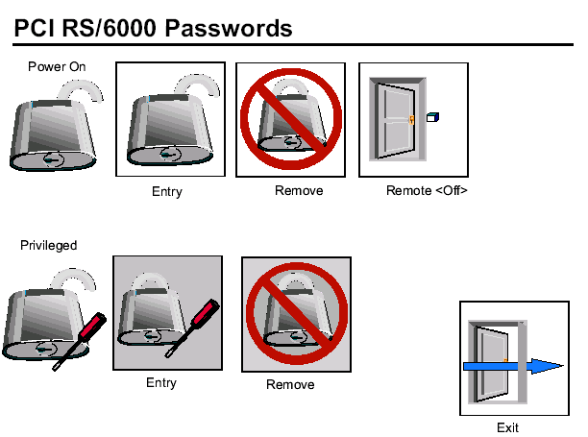
You can use any combination of up to eight characters (A-Z, a-z, and 9-0). After you set a power-on password, you are prompted to enter it each time you power on the system.

Before you can use the system, you must type the correct password and press the Enter key. When you enter the correct password, the system is unlocked and resumes normal operations. If you enter the wrong password, you are prompted to enter the correct one.

After three incorrect entries, you must power off the system and start again.
A power-on password can be set only after system power has been turned off and then on again. You cannot set a power-on password after doing a warm system startup.

The supervisory or privileged password protects against the unauthorized use of the System Management Services program. If you forget the supervisory password, there is no way to reset it. Some models of PCI RS/6000 systems allow you to take the covers off the system, remove the ISA/PCI riser, and remove the battery for at least 30 seconds.
However, be careful as some models require that they be returned to IBM service if the supervisory/privileged password is lost.

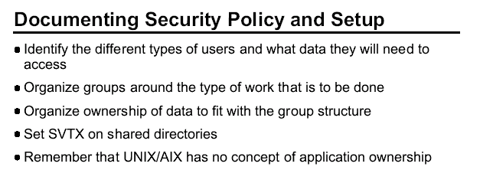
Plan and organize your user and group administration. Every user does not need their own group. Good planning up front reduces any reorganizing of user and groups later on.

Always protect your shared directories by setting the sticky bit. Then users won't be removing each others file accidentally (or on purpose).

