AIX SYSTEM BACKUP AND RESTORE

The data on a computer is usually far more important and expensive to replace than the machine itself. Many companies have gone out of business because they did not plan for disaster recovery. Backup to tape is the cheapest alternative but a duplicate disk or complete system would also provide protection and fast recovery from a disaster.

Backups should be taken before installing/maintaining hardware/software, in case a disk or files accidentally get damaged.

Backups are not just used for disaster recovery. One way of transferring a number of files from one machine to another is to back those files up to diskette, tape or a file on disk and then transfer that backup media to another machine.

When reorganizing the file systems on the disk you need to backup file systems so that they can be deleted and moved to another location.

If you are going to install a number of similar machines, or wish to be able to quickly reinstall a machine then a complete system image backup should be used.

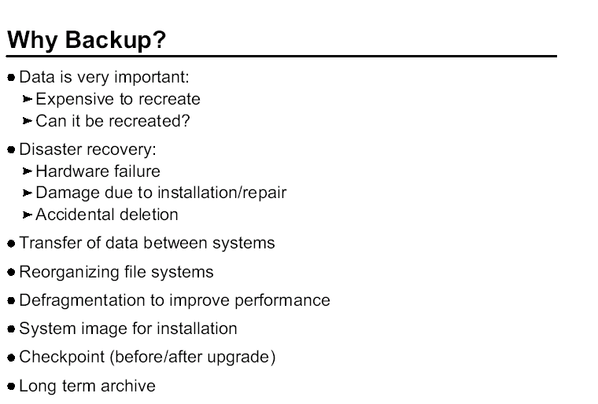

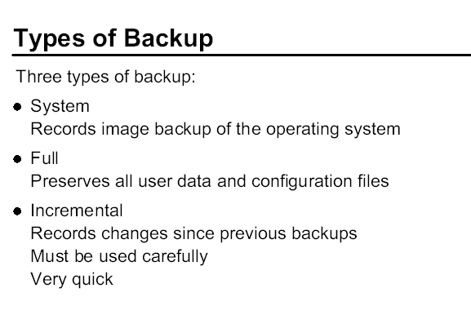

THREE TYPES OF BACKUP:

- System – Record image backup of the operating system
- Full – Preserves all user data and configuration files
- Incremental – Record changes since previous backups Must be used carefully very quick

There are two types of incremental backups:

The first method is to do a full backup. For example, on Sunday, and then for the rest of the week, only backup the changes from the previous day. This method has the advantage of being quick, but there are a lot of tapes involved. Should one of the tapes be missing, you will have problems restoring using the remaining tapes.

The second method again involves taking a full backup on Sunday. However, the other days of the week backup only the changes made since the full backup; that is, since Sunday. The backups take slightly longer than the previous method, and towards the end of the week, if most of your system has changed, then the time taken is similar to a full backup. The restoration procedure does not depend on the tape from the previous day.

The system backup (system image backup) now records and preserves all
system data, including logical volume inter/intra allocation policies, striping, file system setup (nbpi, compression, fragment size) and paging setup.

It is recommended that a system backup should be performed every time the system changes.

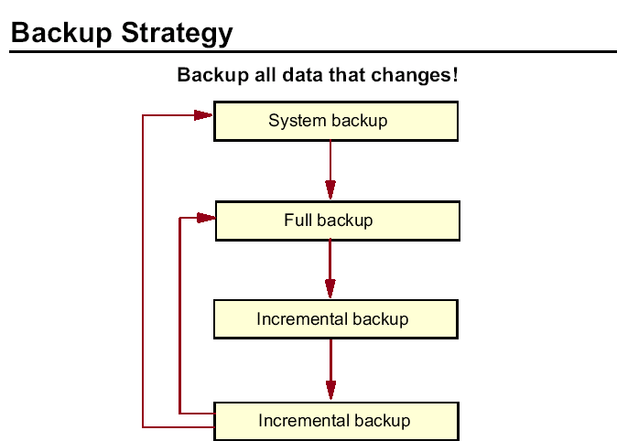

Every organization sets its own backup policy, but a suggested strategy could include doing a system backup when the system is installed or upgraded, then a full backup periodically, perhaps weekly. The incremental backups can be run each day to copy files that have changed since the last incremental backup or the last full backup.

The key to any backup strategy is to ensure the data that is changing is saved regularly while trying to avoid interruptions to users' access to the data on your system.

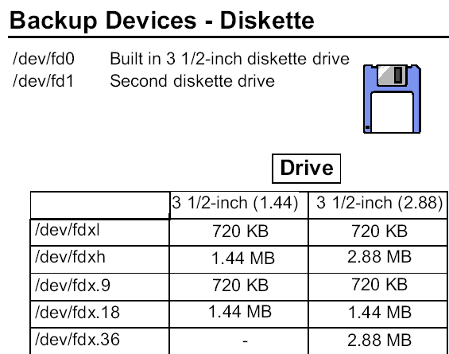

Diskettes can be used to backup data. Of course, this media is only practical when backing up small amounts of data.

The logical device name for a diskette drive is /dev/fdx. Your system most likely has one diskette drive - fd0. When writing to a diskette, the highest density supported is the default value. The chart shows there are multiple logical names associated with the diskette drive that allow writing at different densities.

To read the diskettes on a low-density drive, you must write using the low-density settings.

To format a diskette, use the format command. There is a -l options if you want to format at low density.

The flcopy command is used to copy diskettes (similar to the DOS diskcopy command).
Diskettes can also be formatted using DOS formatting with the command dosformat. AIX can read from and write to DOS diskettes using dosread and doswrite. There is also a dosdir to view the content of the diskette. To use these tools, the fileset bos.dosutil must be installed.

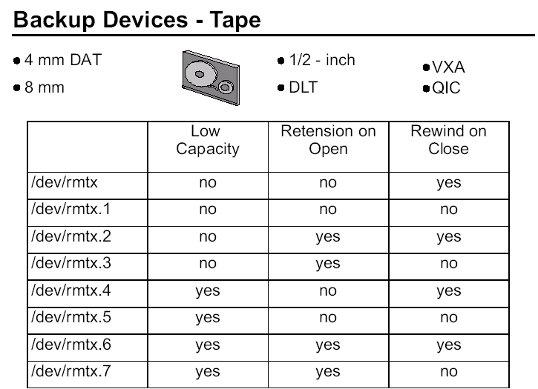

The most common device used for backups are tapes. AIX supports a variety of tape devices, tape subsystems and tape libraries. Here are some highlights of some of the tape technologies.
4 mm DAT (Digital Audio Tape) - can hold up to 40 GB of data with a data transfer rate of 6 MB/sec.
8 mm Tape - can hold up to 40 GB of data with a data transfer rate of 6 MB/sec.
Quarter Inch Cartridge (QIC) - can hold up to 4 GB with a data transfer rate of 380 KB/sec.
DLT - Digital Linear Tape - can hold up to 70 GB at a transfer rate of 10 MB/sec.
Magstar - another tape technology usually used in tape subsystems. It offers up to 420 GB per cartridge with a transfer rate of 15 MB/sec.
VXA Tape Data Cartridge - can hold up to 160 GB with a data transfer rate of 12 MB/sec.
8 mm Data Cartridge with smart clean technology - can hold up to 150 GB with a data transfer rate of 30 MB/sec.

For large scale backups, tape subsystems and tape libraries would the sensible choice. For details on all tape devices supported on the RS/6000, go to: www.ibm.com/storage/tape

The tape devices use the logical device name of rmtx (raw magnetic tape). In the chart, you see the seven additional logical names assigned to each tape device. These names control tape device characteristics:

• Write at low capacity
• Retension the tape (fast forward and rewind before starting the operation)
• Rewind the tape at the finish of the operation

The most common devices that are used are rmtx and rmtx.1. For most tape operations, high capacity and no retension are the norm. Whether or not you want to rewind the tape depends on your particular operation.

Tapes are formatted at the factory. Tape movement can be controlled using tctl or mt commands. And, if there two tape devices, tcopy allows tape to tape transfers.

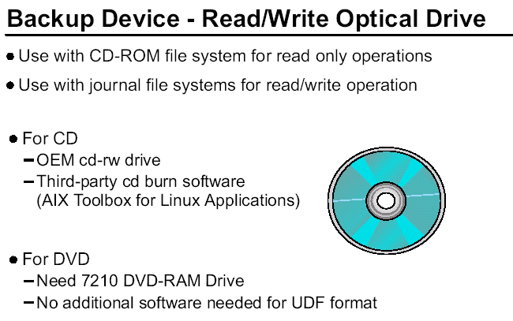

AIX supports read/write optical drives as well as standard CD-ROM. The R/W Optical drives support CD-ROM file systems and JFS file systems. If the optical drive is mounted as a CD-ROM file system, it will be read only.
CD-ROM file system - To use the information on the read/write optical drive like a standard CD-ROM. The steps to access the data is the same as with a regular CD-ROM.

1. Create the file system (smit crcdrfs -or- crfs -v cdrfs -p ro -d DeviceName)
2. Mount the file system (mount mount_point)

JFS file system - To use the read/write optical drive as a read/write device, you must create a volume group using the same commands that used with a hard drive.

1. Make the VG (smit mkvg -or- mkvg -f -y VGName -d 1 DeviceName)

2. Create a file system
(smit crfs -or- crfs -v jfs -g VGName -a size=SizeFileSystem -m MountPoint -A [ yes | no ] -p rw)

the -A option designates whether to automatically mount at system start.

3. Mount the file system

The optical drive VG must be wholly contain on the single optical disk. It cannot span beyond one optical drive.

To burn a backup image onto a CD (IS09660), one must install an OEM drive and software that is capable of CD writes.

To find out what cd writers are supported examine:
/usr/lpp/bos.sysmgt/README.oem_cdwriters.

Two of the cd burner software packages that have been tested with AIX and are provided on the AIX Toolbox for Linux Applications CD are mkisofs and cdrecord. You may alternatively download the software from:
http://www.ibm.com/servers/aix/products/aixos/linux/download.html

Whatever software package is installed you will need to link their executables to the AIX standard command names of /usr/sbin/mkrr_fs
and /usr/sbin/burn_cd. For more details refer to:
/usr/lpp/bos.sysmgt/mkcd.README.

Backing up to DVD is only supported with the IBM 7210 (see next foil) and there is no need to install special software in order to write using the standard UDF format.

In order to boot from a mksysb CD or DVD, you need to be sure that your hardware is at the latest firmware level.

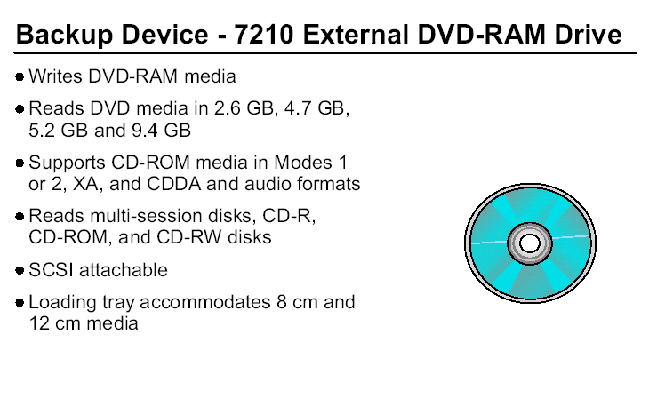

The IBM 7210 External DVD-RAM Drive Model 025 is a DVD-RAM drive designed to provide a high performance storage solution. This self-powered stand-alone drive is designed for the open systems environment, which includes the IBM iSeries, pSeries, AS/400, and RS/6000 servers.

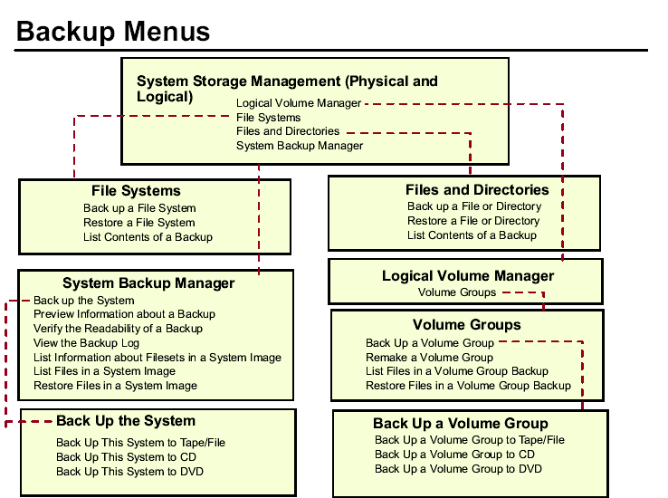

Please note that SMIT screens only show the backup options and not all the options.

Backups can also be performed using the Web-based System Manager.

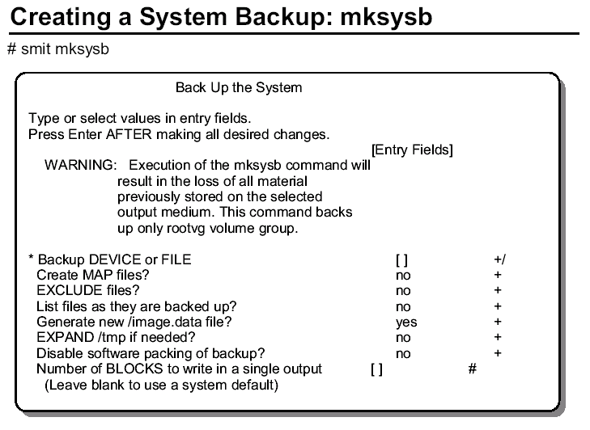

The options on the menu are:

Creation of a MAP File

This option generates a layout mapping of the logical-to-physical partitions for each logical volume in the volume group. This mapping is used to allocate the same logical-to-physical partition mapping when the image is restored.

EXCLUDE Files?

This option excludes the files and directories listed in the /etc/exclude.rootvg file from the system image backup.
List files as they are backed up?
Change the default to see each file listed as it is backed up. Otherwise, you see a percentage-completed progress message while the backup is created. This option is supported at AIX V4.2 and later.

Verify readability if tape device?

Verifies the file header of each file on the backup tape and report any read errors as they occur.

Generate new /image.data file?

If you have already generated a new /image.data file and don't want a new file created, change the default to no.

EXPAND /tmp if needed?

Choose yes if the /tmp file system can automatically expand if necessary during the backup.

Disable software packing of backup?

The default is no, which means the files are packed before they are archived to tape. Files that cannot be compressed are placed in the archive as is. Restoring the archive automatically unpacks the files packed by this option. If the tape drive you are using provides packing or compression, set this field to yes. This option is supported at AIX V4.2 and later.

Number of BLOCKS to write in a single output

This specifies the number of 512 bytes to write in a single output operation, referred to as the block size. If a number is not specified, the backup command uses a default value appropriate for the physical device selected. Larger values result in larger physical transfers to tape devices. The block size must be a multiple of the physical block size of the device being used.

Backup extended attributes?

This is a new option in AIX 5.3. By default, the mksysb and savevg and backup utilities will save any extended attributes. If you plan to restore the to a back-level system which does not understand the format with extended attributes, then this option allows you to override that default behavior.

Only mounted file systems in rootvg are backed up. Use one of the other backup commands to backup other volume groups.

When creating the mksysb image, the /tmp file system must have at least 8.8 MB free space.

Note : - Some older PCI machines cannot boot from a tape device. If you are using one of these older machines, you will need to boot from an installation CD. During the installation, you specify the location of the files to restore - in this case, specify the tape device.

You can use the bootinfo -e command to determine if the machine is bootable from tape. If a “1” is returned, the system is tape bootable. A “0” indicates it is not.

Some documentation indicates that the bootinfo command is not supported in AIX V4.2 and later. However, the command still exists and executes on the AIX V4.3 and 5L systems.

In order to create a bootable tape, sufficient space is required in /tmp. Use the command bosboot -qad hdiskn to determine how much space will be needed in the /tmp directory when creating the mksysb image.

Restrictions on the mksysb utility:

Only mounted file systems are backed up!

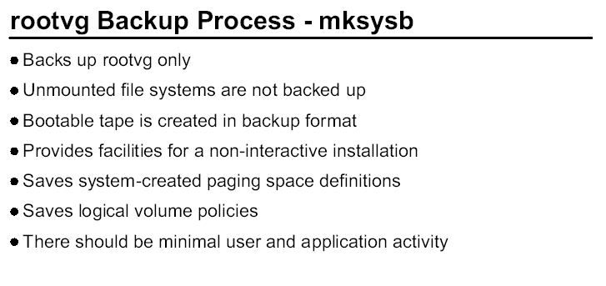

mksysb provides the following functions:
• Saves the definition of the paging space
• Provides a non-interactive installation that gives information required at installation time through a data file
• Saves the inter/intra policy for the logical volumes
• Saves map files for logical volumes if requested by the user
• Provides the ability to shrink the file system and logical volume in a volume group at install time
• Saves the file system block size and number of bytes in inodes
• Saves the file system compression characteristics
• Saves striped logical volume attributes in AIX V4.2 and later
• Allows the user to restore single or multiple files from a system image

The volume group image is saved in backup format. The rootvg is created as an installable image.

If the mksysb command is used for a backup of the source system, it is considered a system backup. However, if the intent of the backup is to provide a customized system for use on other machines, the mksysb is considered a clone. Cloning means preserving either all or some of a system's customized information for use on a different machine. The
mksysb files are system specific.

If the mksysb tape, by itself, is used to clone a machine that is not a hardware clone, it may not work or may not provide support for hardware devices unique to the new machine.

For example, loading a mksysb image made from a uniprocessor machines does not install correctly on a multiprocessor machine because they use different AIX filesets. However, this is an easy problem to resolve. In additional to the mksysb tape, you will also need an AIX installation CD to provide the filesets needed by the other machine. If the CD is also available, during installation the proper fileset is automatically selected and loaded from the CD.

If a system backup is being made to install another system or to reinstall the existing system, a customer can predefine install information so questions at installation time are already answered. This keeps user interaction at the target node to a minimum.
The system backup and BOS Install interact through several files. mksysb saves the data used by the install through taking a snapshot of the current system and its customized state.

The utilities for creating a system backup include messages, SMIT menus, and commands that are packaged in the bos.sysmgt.sysbr option of the bos.sysmgt package. They are separately installable, although this fileset is automatically installed in beginning with AIX V4.3. If your system does not include the mksysb command, install the bos.sysmgt.sysbr option to get mksysb and the bos install routines.

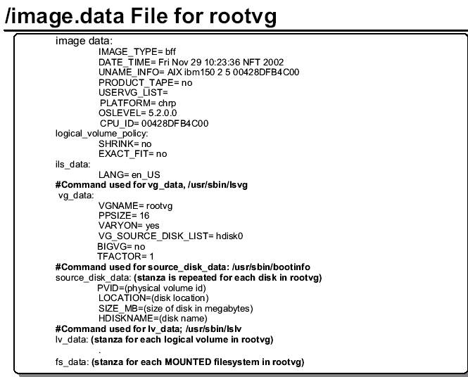

The /image.data file has information used by bos install for creating the target rootvg. The /image.data file, while being flexible, is not intended for every user. The mksysb utility calls mkszfile (if -i or -m options specified) to create an image.data file from existing information. If users edit the image.data file, then they should call the mksysb command without the -i or -m options to use the existing image.data file.

In general, the stanza information found in the /image.data file is generated using one of the lsxx commands; that is, lsvg for the volume group data, lslv for the logical volume data, lsjfs for the file system data and so forth. Some fields like LV_MIN_LPS are created through calculations and are not directly available from commands.

The user can provide additional processing (if required) after bos install by using the BOSINST_FILE= field in the post_install_data stanza or through their own program.

The BOSINST_FILE and SHRINK= fields must be edited by the user before calling mksysb if changes are desired.

logical_volume_policy

Contains information to be used at reinstall time. The SHRINK= field when set to YES, causes the system to create logical volumes and file systems in the volume group based on the values set for each with the LV_MIN_LPs and FS_MIN_SIZE fields.

This option is always set to NO when created by mkszfile. The EXACT_FIT= field when set to YES, causes the system to place the logical volumes on the disk according to the physical partition maps that were generated with the -m flag of the mksysb or mkszfile command.

If the only thing you wish to change is the SHRINK or EXACT_FIT field, there is no need to edit this file. Both of these settings can be controlled by the menus presented during the installation of a mksysb.

vg_data

Contains information about the Volume Group. The VG_SOURCE_DISK_LIST= field specifies the disks that bos install uses on a best effort basis to place the volume Group. If the EXACT_FIT= field is set to YES, the user is warned before installation begins.

lv_data

Contains information about logical volumes. This type of data stanza is also used to contain paging space information. Information about striped logical volumes and large file enabled file systems are placed in this stanza in AIX V4.2 and later.

Note : - During the mksysb backup, the /image.data file is placed in the second file on the mksysb backup tape. During the restore process, this file is loaded into the RAM file system when booting in maintenance mode.

The result of this is that the restore of a system will retain the same LV and file system arrangements as when created.

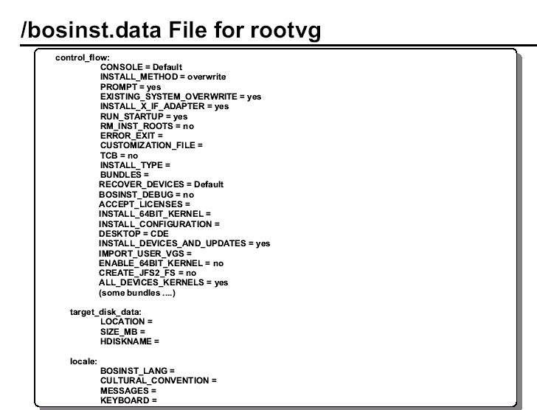

This file allows the administrator to specify the requirements at the target system and how the user interacts with the target system. It provides flexibility by allowing different target hardware to use the same backup image. The system backup utilities simply copy the /bosinst.data into the second file in the rootvg on the mksysb tape. If this file is not in the
root directory, the /usr/lpp/bosinst/bosinst.template is copied to the /bosinst.data.

The sample file shown above has been condensed to highlight key areas. The actual file is well documented with comments contained within the file.
The control_flow stanza contains variables that control the way the installation program works.

CONSOLE specifies the full path name of the device you want to use as the console. For example, /dev/lft0.
INSTALL_METHOD specifies a method of installation: migration, preserve or overwrite. PROMPT specifies whether the installation program uses menus from which you can make choices.

You must fill in values for all variables in the locale and control_flow stanzas if you set the PROMPT variable to no with two exceptions: the ERROR_EXIT and CUSTOMIZATION_FILE variables, which are optional.

EXISTING_SYSTEM_OVERWRITE confirms that the install program overwrites existing files. This variable is only applicable for non-prompted overwrite installation.

INSTALL_X_IF_ADAPTER installs AIXWindows if the selected console is a graphical terminal.

RUN_STARTUP starts the Installation Assistant on first boot after the BOS installation completes. RM_INST_ROOTS removes all files and directories in the /usr/lpp/*/inst_roots directories.

ERROR_EXIT starts an executable program if an error occurs in the installation program.

CUSTOMIZATION_FILE specifies the path name of a customization file you create. The customization file is a script that starts immediately after the installation program concludes.

TCB specifies whether you want to install the Trusted Computing Base.
INSTALL_TYPE specifies what software to install on the machine. The values are full (full-function configuration), client (client configuration), and personal (personal workstation configuration). The full configuration includes all the software in client and personal.

Change full to client or personal if you want to install one of these subsets of the full-function configuration. BUNDLES specifies what software bundles to install. Type the bundle names separated by a space between each name.
RECOVER_DEVICES specifies whether to reconfigure the devices.
BOSINST_DEBUG specifies whether to show debug output during BOS installation.
ACCEPT_LICENSES specifies whether to accept software license agreements during the BOS installation.

INSTALL_64BIT_KERNEL specifies whether to enable the 64-bit kernel and JFS2 filesystems.

INSTALL_CONFIGURATION specifies Default or Minimal installations.
DESKTOP specifies the desktop to be installed. Choices include CDE (the default), NONE, GNOME, and KDE. If you choose GNOME or KDE, you install open-source software.

The target_disk_data stanza contains variables for disks in the machine where the program will install BOS. The default bosinst.data file has one target_disk_data stanza, but you can add new stanzas to install BOS on multiple disks, one stanza for each disk. The installation program determines a target disk by checking the variables in hierarchical order.

For example, if the LOCATION variable specifies a location code, the program installs BOS on that disk, regardless of the remaining variables.
If you accept the default values, which are blank, the installation program chooses a target disk based on the initial hardware query.

LOCATION specifies a location code for the disk where the program will install BOS. SIZE_MB specifies the formatted size of the disk (in megabytes) where the program will install BOS.

HDISKNAME specifies the path name of the target disk.
The locale stanza contains variables for the primary language the installed machine will use.

BOSINST_LANG specifies the language the installation program uses for prompts, menus and error messages.

CULTURAL_CONVENTION specifies the primary locale to install.
MESSAGES specifies the locale for the messages catalogs to install.
KEYBOARD specifies the keyboard map to install.

You must install the Base Operating System (BOS) before you can access and modify the default bosinst.data file. Once you have installed BOS, retrieve and edit the file like any other ASCII file. There are basically three different ways that you will use a customized /bosinst.data file.

• Customize the bosinst.data file, then create a backup image of the system to use in subsequent installations from a backup tape.
• Customize a bosinst.data file for each client you want to install via the network.
• Customize the bosinst.data file, then copy the modified file to a diskette that supplements your installation medium, either tape or CD-ROM. Note that if you use this method then you must also have on your diskette a file called signature.

The file signature must contain the word data.
With both the /image.data and the /bosinst.data files created, the reinstallation of AIX Version 4 and later can be made unattended.

The procedure to accomplish this is as follows:

1. Edit the bosinst.data file as follows:
a. Set CONSOLE=/dev/lft0 or CONSOLE=/dev/tty0 according to your system.
b. Set PROMPT=no
c. Set EXISTING_SYSTEM_OVERWRITE=yes
d. Set RUN_STARTUP=no
2. Create the signature file:
echo "data" > signature
3. Create the floppy diskette with
ls ./bosinst.data ./signature | backup -iqv

4. Run the command mksysb /dev/rmt0.1

The assumption for 3) is that there is already a preformatted diskette in the drive. The assumption for 4) is that there is a tape in the first tape drive and that it is large enough to hold all the data for the root volume group.

Having completed these steps, the diskette is usable with the backup tape.
The diskette is put in the target system's diskette drive prior to starting the installation of the target machine. When the target machine is booted from the install media, the BOS install program uses the diskette file rather than the default /bosinst.data file shipped with the install media.

The purpose of the signature file is to verify that this really is a bosinst.data diskette. You can break out of an unassisted install by typing 000 <Enter> when you see the startup symbols \ | / on the display.

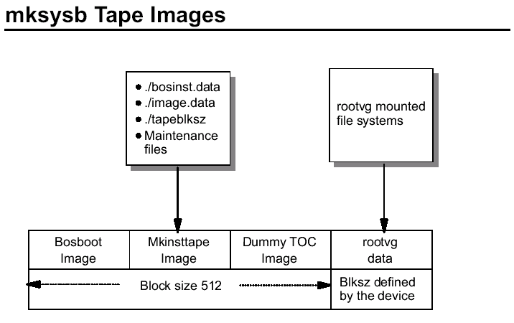

There will be four images on the mksysb tape, and the fourth image will contain only rootvg jfs and jfs2 mounted file systems. The following is a description of mksysb's four images.

1. Image #1: The bosboot image contains a copy of the system's kernel and specific device drivers, allowing the user to boot from this tape.

2. Image #2: The mkinsttape image contains files to be loaded into the RAM file system when booting in maintenance. Example files in this image are bosinst.data, image.data or tapeblksz, which contains the blocksize for the fourth image.

3. Image #3: The dummy image contains a single file containing the words "dummy toc". This image is used to make the mksysb tape contain the same number of images as a BOS install tape.

4. Image #4: The rootvg image contains data from the rootvg volume group (mounted jfs and jfs2 file systems only).

The blocksize for the first three images is set to 512 bytes. The blocksize for the rootvg image is determined by the tape device.

If you are not sure what blocksize is used for the rootvg image, restore the file tapeblksz from the second image:

# chdev -l rmt0 -a block_size=512
# tctl -f /dev/rmt0 rewind
# restore -s2 -xqvf /dev/rmt0.1 ./tapeblksz
# cat tapeblksz
1024

In this example the blocksize used in the fourth image is 1024.

ADDITIONAL INFORMATION

This is important if you want to restore one file from the image rather than the whole image. If the tape is positioned to the fourth file (rootvg data), files can be retrieved using restore command.

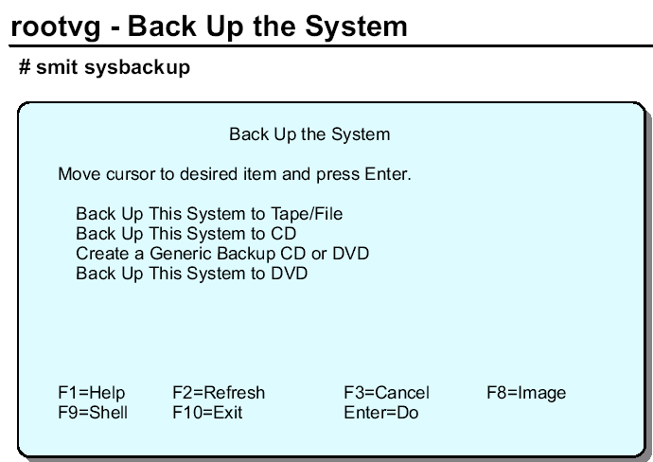

In AIX V5L you can use smit sysbackup to preselect if you like to back up the system (rootvg) to Tape/File, CD or DVD.

On the following foils you see:

1. Back up the System to Tape/File
2. Back up a Volume Group to Tape/File
3. Restore the System from Tape
4. Restore a Volume Group from Tape
5. Back up the System to CD
6. Back up the System to ISO9660 DVD
7. Back up the System to UDF DVD
8. Back up a Volume Group to CD
9. Back up a Volume Group to ISO9660 DVD
10.Back up a Volume Group to UDF DVD

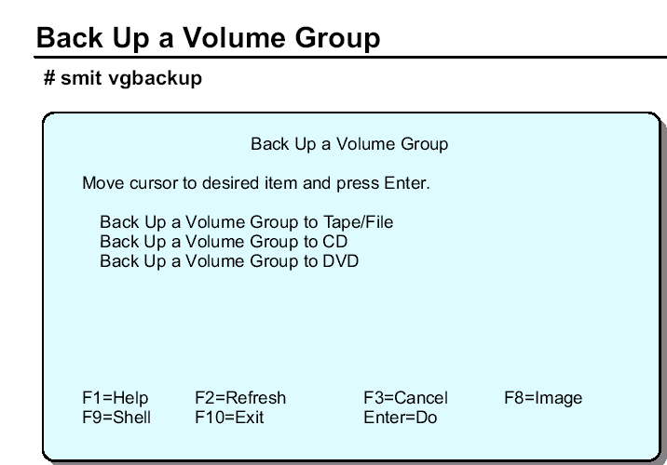

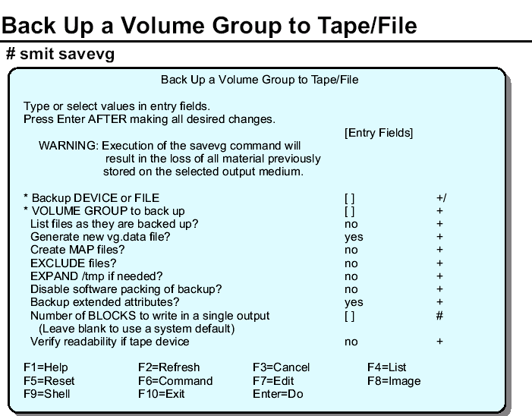

The savevg SMIT screen looks very similar to the mksysb SMIT screen. This is because they are both performing a volume group backup except mksysb creates bootable images.

The command that SMIT is using is savevg. Listed below are some of the differences between the mksysb screen and this screen.

VOLUME GROUP to back up - name the volume you wish to back up.
Generate new vg.data file - This file is equivalent to the image.data file for rootvg. Unless you have a customized file that you wish to use, let SMIT (savevg) create this file for you.

The file will be called /tmp/vgdata/vg_name/vg_name.data. This file can be created by running mkvgdata vg_name.

EXCLUDE files - this allows you exclude file (during the backup) located in mounted file systems within the volume group. Create a file called /etc/exclude.vg_name and add the list of filenames that are not wanted.

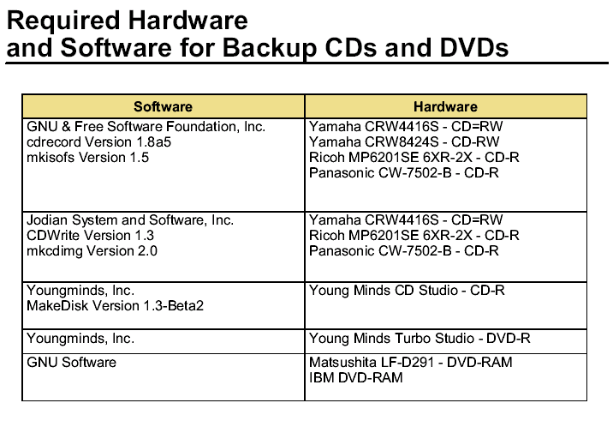

mkcd Command

Purpose

Creates a multi-volume CD (or CDs) from a mksysb or savevg backup image.

Examples

To generate a bootable system backup to the CD-R device named
/dev/cd1, enter:

mkcd -d /dev/cd1

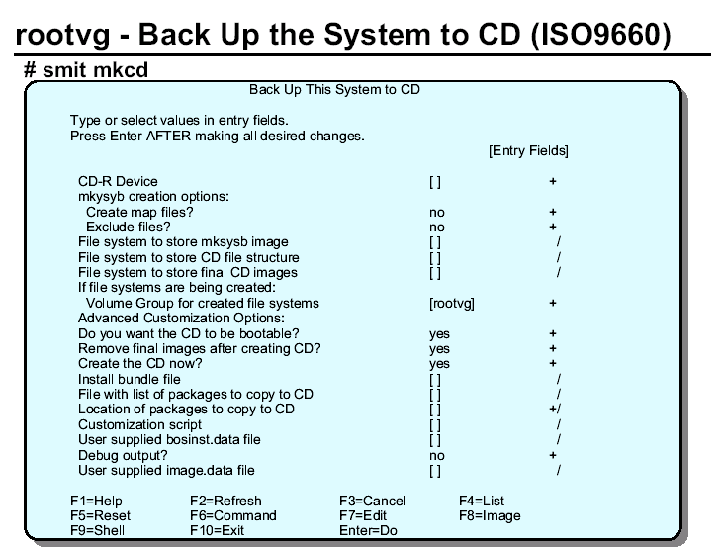

Backup volume groups in ISO9660 format on CD or DVD-RAM requires a significant amount of space. As such the mkcd command allow you to specify where you want to create the various structures and images needed to:
1. Create backup image
2. Create CD file system and copy backup to it
3. Create CD image on hard disk
4. Burn to media

Be sure you have sufficient space in the selected filesystems to hold the pre-burn data.

To generate a non-bootable volume group backup of the volume group
myvg to /dev/cd1, enter:

mkcd -d /dev/cd1 -v myvg

Note: All savevg backup images are non-bootable.

mkdvd Command

Purpose

Creates a multi-volume DVD (or DVDs) from a mksysb or savevg backup image.

Examples

To generate a bootable system backup to the DVD-R device named
/dev/cd1, enter:

mkdvd -d /dev/cd1

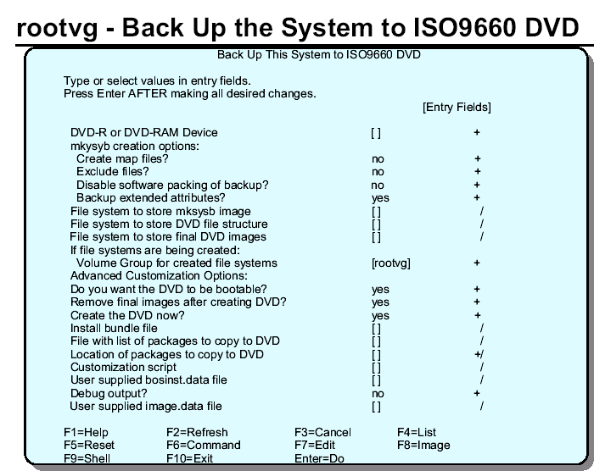

The smit fastpath for this panel is: smit mkdvd, when prompted choose the UDF option. Backup volume groups in UDF (Universal Disk Format) format on DVD-RAM requires only the space for the backup image.

1. Create backup image.
2. Burn to media.

Allow modification of files such as bosinst.data, image.data, and vgname.data

To generate a non-bootable volume group backup of the volume group
myvg to /dev/cd1, enter:

mkdvd -d /dev/cd1 -v myvg

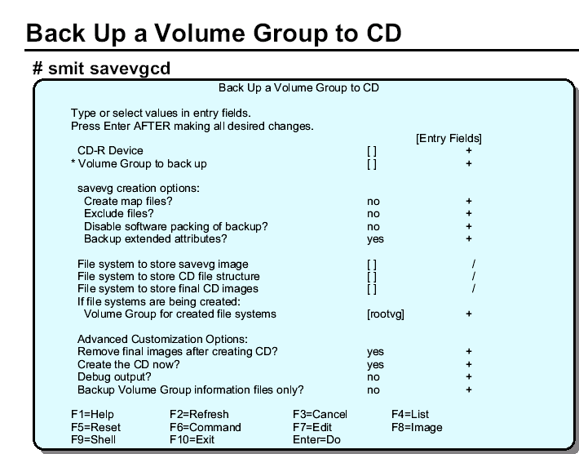

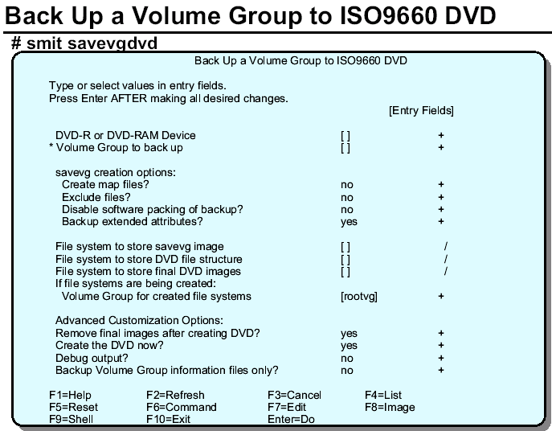

The gzip Command

Purpose

compress or expand files

Gzip reduces the size of the named files using Lempel-Ziv coding (LZ77). Whenever possible, each file is replaced by one with the extension .gz, while keeping the same ownership modes, access and modification times Gzip will only attempt to compress regular files. In particular, it will ignore symbolic links

If the compressed file name is too long for its file system, gzip truncates it. Gzip attempts to truncate only the parts of the file name longer than 3 characters. (A part is delimited by dots.) If the name consists of small parts only, the longest parts are truncated. For example, if file names are limited to 14 characters, gzip.msdos.exe is compressed to gzi.msd.exe.gz. Names are not truncated on systems which do not have a limit on file name length

Compressed files can be restored to their original form using gzip -d or gunzip or zcat

Multiple compressed files can be concatenated. In this case, gunzip will extract all members at once. For example:
gzip -c file1 > foo.gz
gzip -c file2 >> foo.gz
Then
gunzip -c foo
is equivalent to
cat file1 file2
If you want to recompress concatenated files to get better compression, do:
gzip -cd old.gz | gzip > new.gz

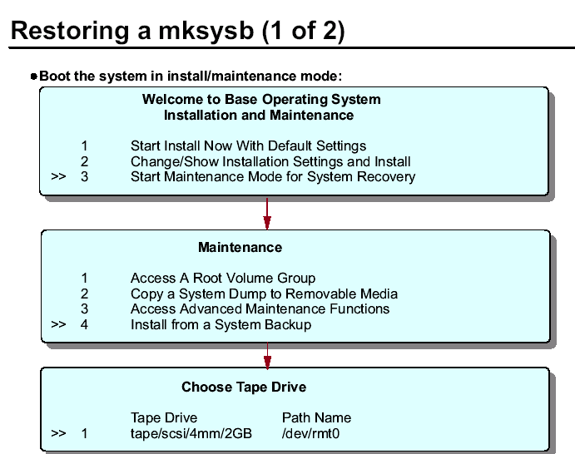

To restore a mksysb image, boot the machine just as if you were performing an installation.

Be sure your boot list contains the tape device before the hard drive (run bootlist –om normal to display). Then insert the mksysb tape and power the machine on. The machine boots from the tape and prompts you to define the console and select a language for installation. Once you have answered those questions, then the Installation and Maintenance menu is presented.

Also, you can boot from an installation CD. The CD presents the same screens. Just be sure to put the mksysb tape in the tape drive before answering the last question.

Select 3 Start Maintenance Mode for System Recovery, then 4 Install from a System Backup and select the tape drive that contains the mksysb tape.

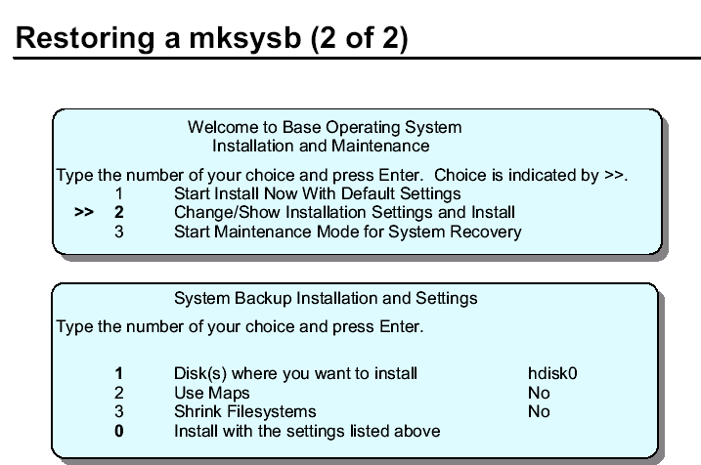

After selecting the tape drive (and a language, which is not shown on the visuals), you return to the Installation and Maintenance menu. Now select option 2.

From the System Backup and Installation and Settings menu, select 1 and provide the disks where you want to install. Be sure to select all disks where you want to install.
If your rootvg was mirrored, you need to select both disks.

Two other options can be enabled in this menu:

1. The option Use Maps lets you use the map file created (if you did create them) during the backup process of the mksysb tape. The default is no.

2. The option Shrink Filesystems installs the file systems using the minimum required space. The default is no. If yes, all file systems in rootvg are shrunk. So remember after the restore, evaluate the current file system sizes. You might need to increase their sizes.

At the end, select option 0 (Install with the settings above). Your mksysb image is restored. The system then reboots.

Note: The total restore time varies from system to system. A good rule of thumb is twice the amount of time it took to create the mksysb.

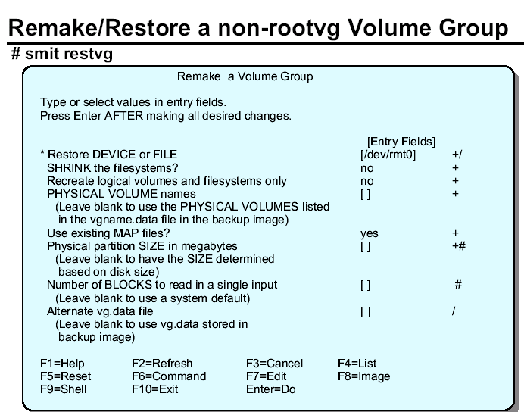

SHRINK the filesystems - When restoring the volume group, like with rootvg, you have the option to shrink the file system contained in the volume group. Always be sure to check the size of the file systems after the restore is complete. You might need to increase them once again.

PHYSICAL VOLUME names - If left blank, the VG goes back to the disks it came from. If you need to change the location, this is the place to do it.
Use existing MAP files - If map files exists, they are used by default during recovery.
If you don't want to use them, set this selection to no.

Physical partition SIZE determined based on disk size - AIX properly sizes the PPs for the disk it is using. If you prefer to have a larger PP size than the standard, you can set it here. If for example you have a 4.5 GB drive, the partition size is 8 MB. If you want it to be 16 MB, you can set it here.

This characteristic makes it easy to resize the partitions in a VG. If you want to move the VG to a larger disk, the PP adjusts automatically during the restore.

Restore Individual File From System Image

#smit restmksysb

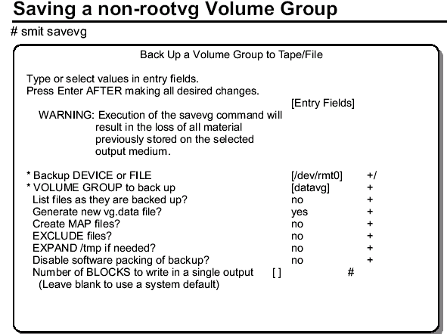

In the example we save the volume group datavg to the tape device /dev/rmt0.

The command that smit executes is the following:

# savevg -i -f/dev/rmt0 datavg

The option -i indicates the mkvgdata command is executed before saving the data. This command behaves like mkszfile. It creates a file vgname.data (in our example the name is datavg.data) that contains information about the volume group. This file is located in /tmp/vgdata/vgname, for example, /tmp/vgdata/datavg.

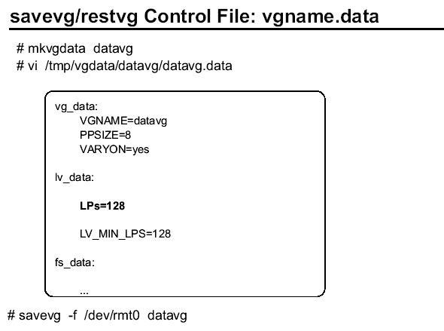

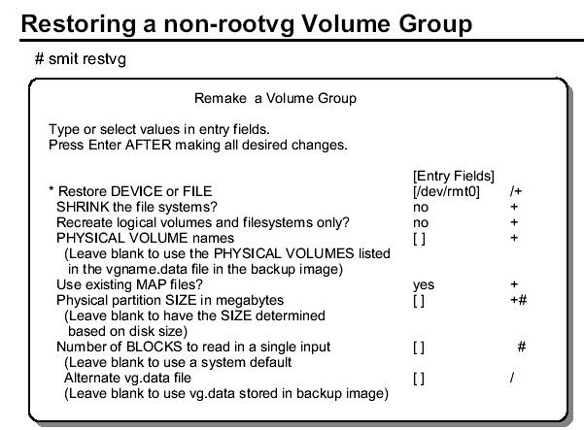

BACKUP SUPPORT TWO DIFFERENT METHODS:

- Backup by name
- Backup by inode ( also call a file system backup)

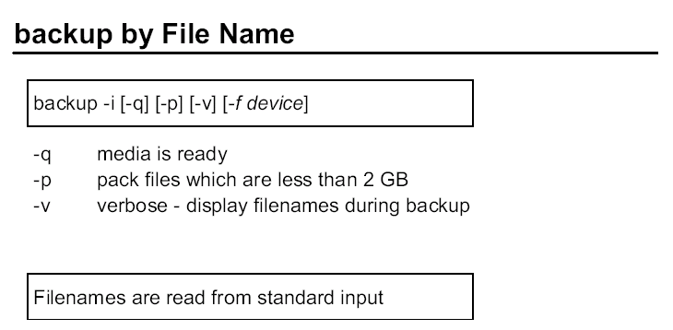

The backup command is the preferred command for making backups of AIX files and directories. Backup supports two different methods - backup by name and backup by inode (also call a file system backup). When performing a backup by name, the files must be in a mounted file system to be backed up. Backups by inode backup file systems even when they are unmounted.

The syntax is shown for the backup by name.

The -i option is used to indicate a backup by name.
The -q option is for quiet. It suppresses the comment, press Enter to continue, that displays when the backup command is executed. This is helpful for automated backups.
The -p option compresses files during the backup process. It can only compress files smaller than 2 GB. Also, don't use the -p option on active file systems. Modifying a file during the compression may corrupt the file and make it unusable on recovery.
The -v option displays the files and pathnames to standard out as they are backed up.

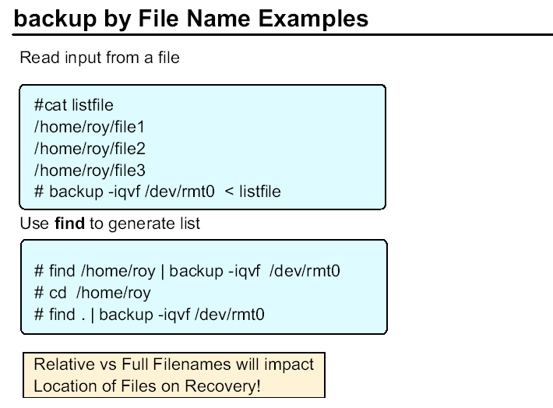

The list of files backup uses can be supplied by a file or by commands. The graphics provides a sample of each.

In the first example, the file listfile contains the files we want to back up. That is fed into the backup command by using a redirection (<).

In the second example, there are two examples that can be used to back up the same data using the find command to generate the file list. Both commands back up the files stored in /home/roy.

Even though both find examples save the same data, the filenames will be stored differently. There are two types of filenames - relative and full (or absolute).

The difference is a full pathname shows the location referenced from the root directory. Basically, the name starts with a slash (/). The relative pathname shows the location referenced by the current directory. This distinction is important when you try to recover the data.
Full pathname backups restore to the same location in the directory structure since their position is referenced from the root directory. But, a relative pathname file is restored based upon the current directory when the restore command is issued. Full pathnames provide certainty of location and relative pathnames provided flexibility.

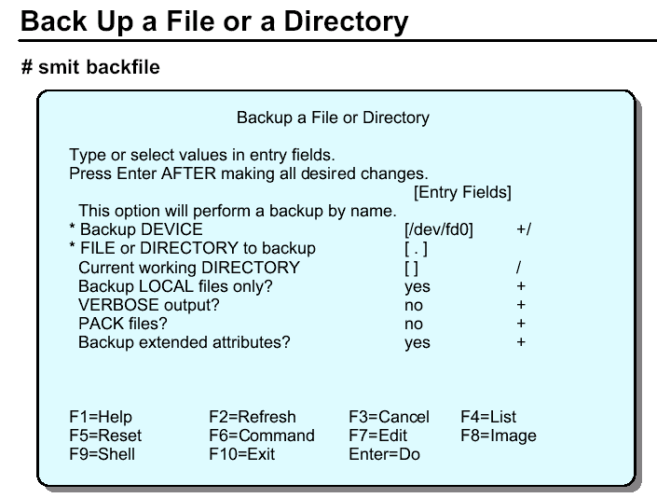

You can perform backups through SMIT.

FILE or DIRECTORY to backup - This is a parameter for the find command that will run behind the scenes. The dot (.) indicates to start the find command from the current directory. This will provide a relative pathname backup. If a full pathname was used here (like /home/roy) then the names would be stored with full pathnames.

Current working DIRECTORY - performs a cd to that directory before starting the backup. If you want a backup from the current directory (.), and you want to make sure you are in the right directory, you can put the name of the directory here.
Backup LOCAL files only - ignores any network file systems. Files backed up are from the local system only.

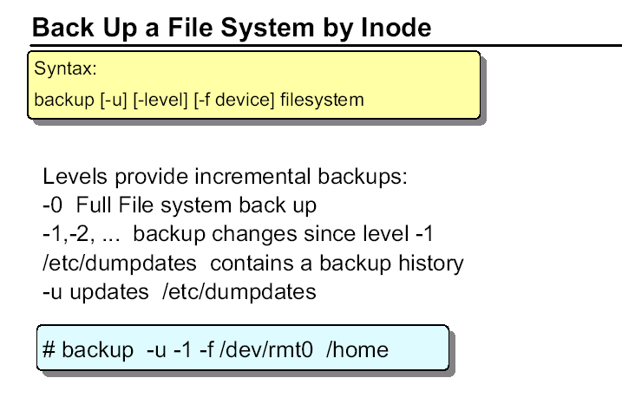
If you do not specify the -i option, the backup command will perform a file system backup by inode.

The -level option allows you to perform incremental backups. The -0 level backs up all files in the file system. The -1 level backs up all files changed since the last -0 backup, and so on. (If you do not specify a level, -9 is assumed.)

You should unmount the file system before you use backup by inode. This is recommended for user-created logical volumes /dev/lvnn and system logical volumes (other than /) otherwise errors in mapping on restore may occur.
This is not required for / (it's difficult to unmount it in any case!). If you do not specify a file system, the root / is backed up. The file system parameter can specify either the physical device name or the directory on which the file system is mounted. You must have read access to the file system device in order to perform backups by inode.
The -u option causes backup to update the /etc/dumpdates file to record the date and level of the last inode backup for that file system. This file holds file system backup information for the backup command. The information included in this file is the name of the file system, the level number of the last backup, and the date of the incremental backup.

If you do not specify a level, -9 is assumed.

# backup –u –1 –f /dev/rmt0 /home

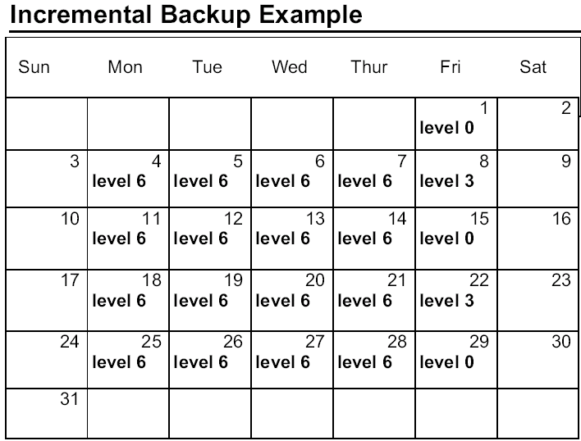

You can use the -level parameter to back up either all files on the system (a full backup) or only the files that have been modified since a specific full backup (an incremental backup).

The possible levels are 0 through 9. If you do not supply a level the default level is 9.

A level 0 (zero) backup includes all files in the file system. An n level backup includes all files modified since the last n-1 backup or lower. The levels, in conjunction with the -u flag, provide a way to maintain a hierarchy or incremental backups for each file system.

How backup performs in calendar days:-

level 0 backup is performed on the first Friday, and thereafter every other
Friday.

level 6 is performed on each day of the week except on the Fridays that a
Full backup is not carried out

level 3 backup is performed during the first full week, the level 6 backup on Monday will backup all files modified since the level 0 backup on the previous Friday.

Each level 6 backup Tuesday through Thursday will backup all files that have been modified since the last n-1 backup or lower (in this case level 0).

The first level 3 backup of the month will backup all files modified since the level 0 backup. The remaining level 3 backups will backup all those files modified since the last level 0 backup.

During the second full week, the level 6 backups on Monday through Thursday will backup all files that were modified since the last level 3 backup. The level 3 backups on Friday will backup everything since the last level 0.

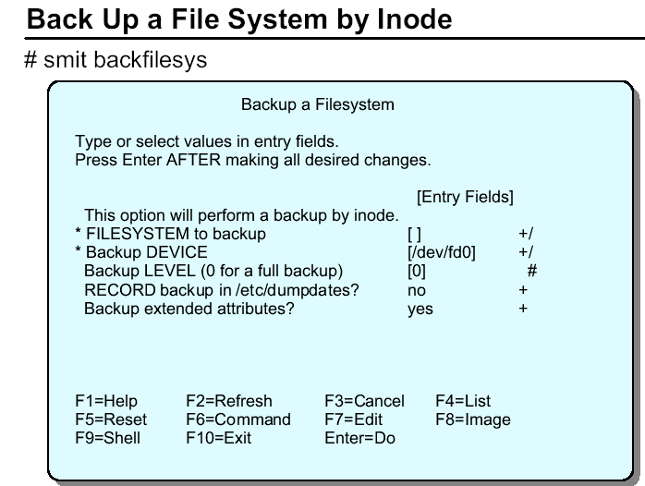

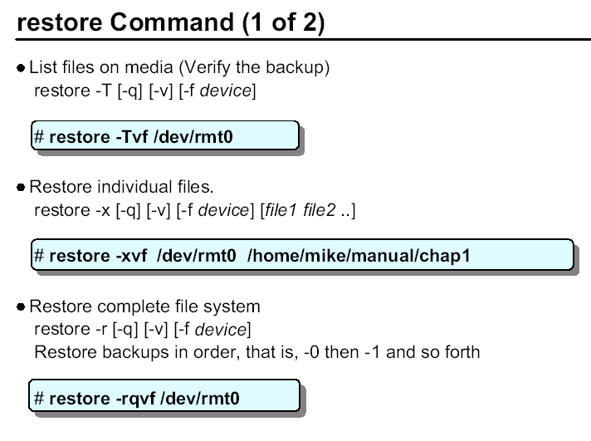
The restore command is used to restore data backed up with the backup command.

restore -T shows the contents of the media and display the list of files.

restore -x can be used to restore selective files from the backup. The file names and paths on the backup are preserved on the restore. If the backup was created with relative path names, then the files are restored relative to the current directory when the restore is issued. restore -x can be used to restore selected files from a backup by name and a filesystem backup.

restore -r works with backups by inode. It ensures that the proper order is used to recover incremental backups. During the restore process, a file called restoresymtable is created in the root directory (top level directory) of the file system.
This file is checked each time restore -r is run to ensure that the recovery sequence is correct. The recovery should progress in ascending order by level number. When you have recovered the entire file system, remove the restoresymtable file to be ready for future recoveries. Otherwise, the
next time you need to restore a level 0, you are told you are not going in the correct sequence.

Make sure the file system exists and is mounted before recovering a file system backup. The data will be recovered into the existing directory structure using the file names. If the file system is not mounted, the data goes into a different file system. Be careful! restore -i is another option available when working with an inode backup. This allows for an interactive restore.

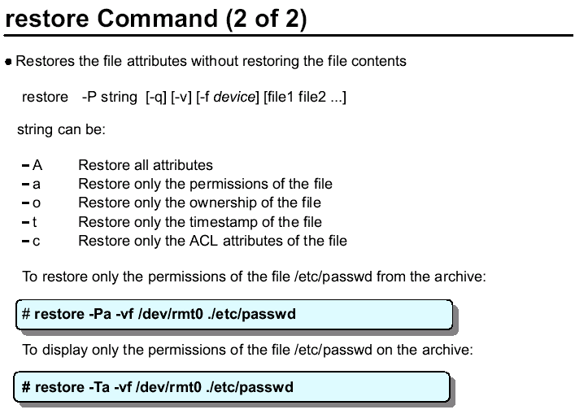

These options are only available on AIX V5.2.

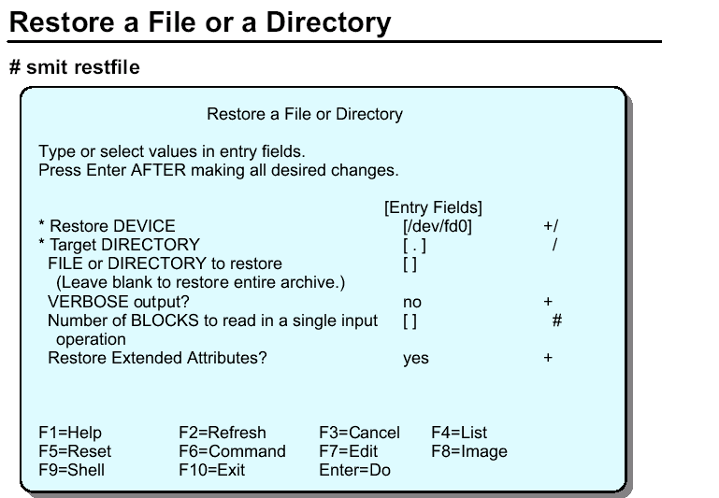

There is another SMIT screen (fastpath smit restfilesys), which, as the name suggests, can be used to restore an entire file system rather than a file or a directory.

The screen contents are identical to this screen (smit restfile) apart from the one option FILE or DIRECTORY to restore, which does not appear on the restore a file system screen. All other options are present.

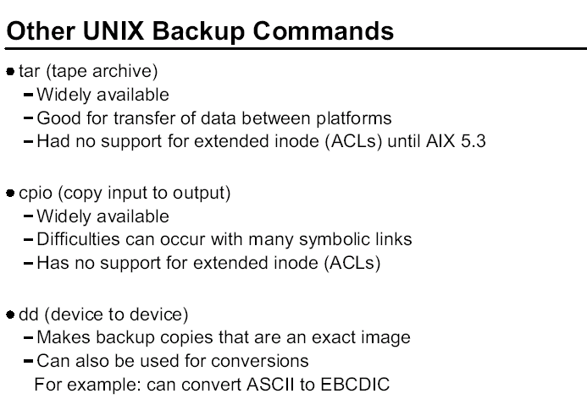

The AIX backup tool is preferred for an AIX backup intended to be used exclusively on AIX machines. AIX supports access control lists (ACL) and Trusted Computing Base (TCB) which provide additional security-related features for AIX files and directories.
Only the backup command supports these additional security features. If you are using ACLs or TCB, you need to use backup or these elements of security are lost during the backup.

AIX does support other generic UNIX backup tools. For backups that are recovered on another UNIX operating system, these tools would need to be used since only AIX supports backup and restore.

tar is widely used throughout UNIX and is supported on AIX as well. cpio is also widely used and is also in AIX. Neither support ACLs or TCB. Also,

cpio has difficulties following symbolic links. It may not have enough memory to follow the link and the link is lost in the backup.

dd is used to copy and convert data byte-by-byte.

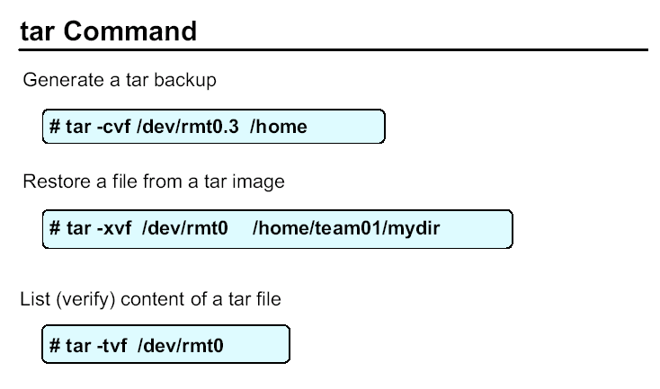
The tar command only works with mounted file systems.

Here is a list of the commonly use options:

-c create a tar backup
-x extract (restore) a file(s) from a tar file
-t reads the content of the tar file (verify the backup)
-v verbose output - displays files as they are backed up and restored
-f identify the file or device holding the tar image

To perform a tar backup, use the -c option. The -f option can specify a device (like rmt0) or a file in a directory. The tar command does recursive backups. In the example, /home is the starting point for the tar command. It backs up all of /home and its subdirectories, and so on.

When recovering, use the -x to extract a file. If you want just one file, name it on the command line. If you want a directory and all of its subdirectories, name it. The example shows the recovery of the /home/team01/mydir directory. If no file is named, then the entire tar image is restored.

To verify the tar image, use -t. In the example, the content of rmt0 is displayed. With -t, no files are actually recovered.

The tar command has been modified to exit now with error when trying to extract a file that is not part of the tar archive.

# tar -xvf /dev/rmt0 aaa bbb ccc

File aaa not present in the archive.
File bbb not present in the archive.
File ccc not present in the archive.

# echo $?
3

AIX V5.3 has provided some very nice enhancements to the tar utility.
Here is a list of the new options:

-D suppress recursive processing (only current directory)
-R use recursive processing (default)
-L <filename> input list of filenames to process
-x exclude list of files or directories to not be copied
-U use extended ACLs

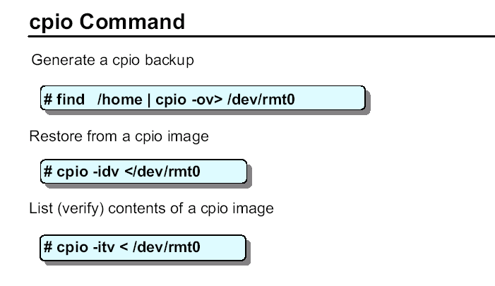

The cpio tool is another generic UNIX tool. cpio stands for copy input/output.
Some of the common options that are used with cpio:
-o create a cpio image (output)
-i read from a cpio image (input)
-t read (verify) the content of a cpio image
-v verbose output - list files during backup and restore operations
-d create necessary directories when recovering an image
-m retain the original modification times associated with files contained in a cpio image. Without the -m option, all files will have modification times associated with the time they were restored

cpio must be fed a list of files much like the backup command. The find command is frequently used to do this. Instead of using the -f option like tar and backup, cpio uses the redirection symbol (>).

Take a look at the examples:

To create the cpio image the find command recursively lists all files in the /home directory. cpio then creates its output, -o, on /dev/rmt0.

To restore from a cpio image, the -i is used to read in from the image. The -d creates directories and -m retains the time stamps. If a file is named, then only the file is restored. If no file is named, the entire image is restored.
To verify or read the content of the cpio image, use the -t option.
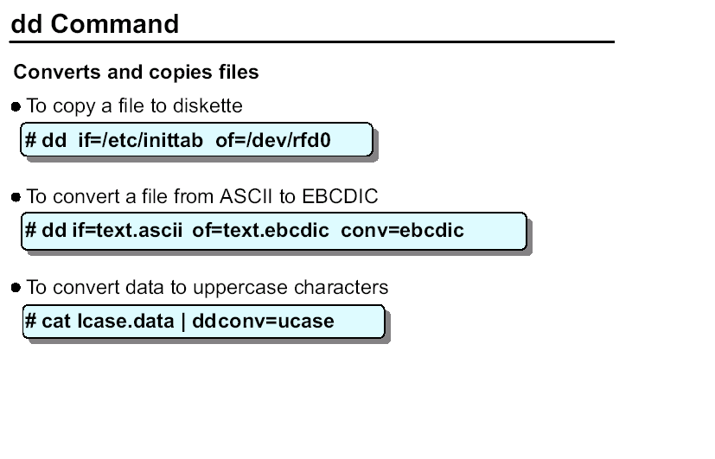
The dd command reads in standard input or the specified input file, converts it, and then writes to standard out or the named output.

The common options are:

if= specifies the input file
of= specifies the output file
conv= designate the conversion to be done

In the first example, the file /etc/inittab is copied to the floppy diskette.
In the second example, the file text.ascii is converted into EBCDIC and is written to a file called ebcdic.text.

In the last example, no output or input file is specified so standard out and standard in is used. The file containing lower case characters, lcase, is converted into uppercase characters and displayed to standard out.

dd is also useful when you need to copy specific blocks of data. For example, if a file systems superblock (stored in the first block of the file system) is corrupt, a copy is kept at the 31st block. The dd command can copy that 31st block back to the 1st to repair the file system. The command is:

dd count=1 bs=4k skip=31 seek=1 if=/dev/hd4 of=/dev/hd4

dd can span volumes with the span=yes parameter on the command line.

The pax command

pax — Extracts, writes, and lists archive files; copies files and directory hierarchies

The -r and -w flags specify the archive operation performed by the pax command.

-r Reads an archive file from the standard input
-w Writes files to the standard output in the specified archive format.
-f archive Specifies the path of an archive file to be used instead of standard input (when the -w flag is not specified) or the standard output (when the -w flag is specified but the -r flag is not). When specified with the -a flag, any files written to the archive are appended to the end of the archive.

Examples

To copy the contents of the current directory to the tape drive, enter:
pax -w -f /dev/rmt/0m .
To copy the olddir directory hierarchy to newdir enter:
#mkdir newdir
#cd olddir
#pax -rw olddir newdir

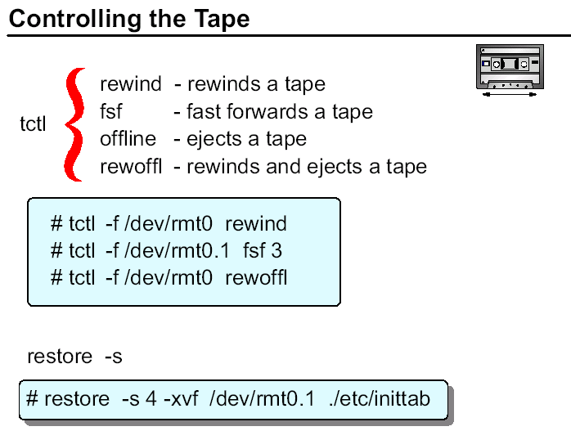

The tape control, tctl, command is used to position the tape and eject the tape. All of the backup commands addressed so far assume the tape was positioned correctly. None of those commands reads the entire tape, rather they only look at the tape file where the tape is positions. To ensure you position it correctly, be sure to document the content and order of the data on the tape.

The tctl command has many options. These are ones more commonly used.

The rewind option is generally the first place to start. This ensures you start from the beginning.

The fsf moves the tape forward. It counts end-of-file markers. In the example, fsf 3 positions the tape to the beginning of the fourth file.
The offline and rewoffl options will eject the tape.
The restore command has the capability to position a tape as well. The -s option is used to seek the file specified. In the example above, the fourth file on the tape is read and the ./etc/inittab file is restored.

Both the fsf example and the restore -s example are both positioning the tape to the same location. If they were being used on a mksysb tape, this is how you can restore an individual file from the tape.

There is also a tcopy command that can be used to copy a tape to another tape. To do this, you must have two tape devices. The syntax is tcopy source target.

The tcopy command can be given just a source. When this is done, the entire tape is read and a report showing the number of files and blocks sizes is displayed.

